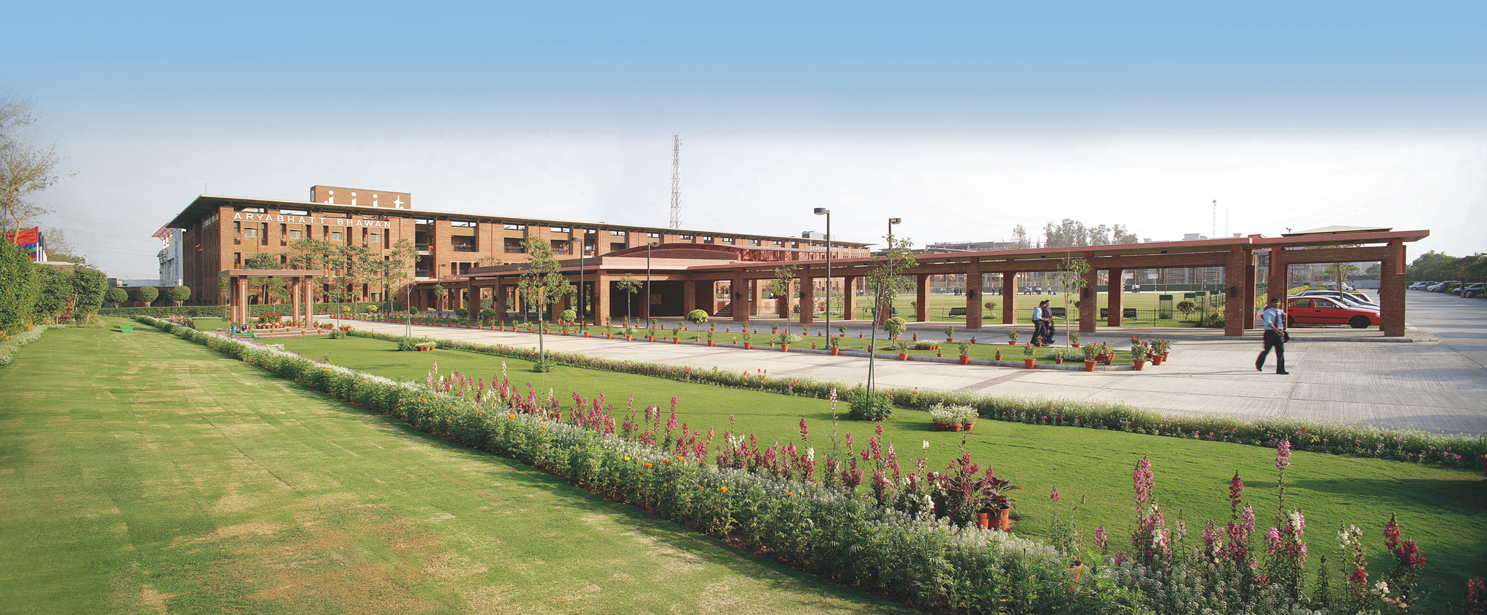
BASIC INFORMATION IN BRIEF
Name : Jaypee Institute of Information Technology, Noida
(Declared Deemed to be University u/s 3 of the UGC Act, 1956)
Year of Establishment : August 2001
Status : Deemed University, with effect from 01 Nov 2004
Location : A-10, Sector-62, Noida
Pin code : 201307
District : Gautam Budha Nagar
State : Uttar Pradesh

Officers of the Institute
Chancellor Sh. Manoj Gaur
Executive Chairman, Jaypee Group of Companies,
and Managing Trustee, Jaiprakash Sewa
Sansthan (JSS)

Vice Chancellor : Prof JP Gupta
Registrar : Col Vijay Kumar (Retd), SM, VSM
Finance Officer : Sh. SJS Soni

Tele/Fax/Website
Vice Chancellor : (O) 0120-2594105
(R) 011-22711251

Registrar : (O) 0120-2594130
0120-2700973-976 Ext-130
(R) 0120-2700973-976 Ext-405

EPBAX : 0120-2400973-976

Fax : 0120-2400986

Website : www.jiit.ac.in

INTRODUCTION

Genesis
The Jaypee Group of Companies has consistently displayed full awareness of its social responsibilities through the Jaiprakash Sewa Sansthan (JSS), a ‘not for profit’ Trust. The Group believes that Education is the cornerstone to economic development and which alone can assist build India into a developed nation.
With the thought of using technology and management effectively, the visionary founder of the JSS, Shri Jaiprakash Gaur Ji set up three higher technical institutes to host the best of faculty, students and educational infrastructure to ensure creation, generation, dissemination and application of knowledge to mould the world leaders of tomorrow.
- Jaypee Institute of Information Technology (JIIT) was the first amongst three Institutes of higher technical education, raised by the Jaiprakash Sewa Sansthan (JSS).
- The Institute commenced its academic activities from August 2001. Initially it functioned as a Constituent Centre of Jaypee University of Information Technology (JUIT), at Waknaghat (HP). Satisfied with the highest standards of professional education, supporting infrastructure and based on recommendation of AICTE and UGC, the Ministry of Human Resource Development (MHRD), accorded it the status of “Deemed University” through its notification No. F-9-27/2000-U.3 dated 01 November 2004 initially for 3 years and extended the status for a further period of 5 years vide Notification of Even No. dated October 01, 2008.

About Jaiprakash Sewa Sansthan (JSS)
- ‘JSS’ a ‘not-for-profit Trust’ envisioned by Shri Jaiprakash Gaur Ji, the Founder Chairman of the Jaypee Group, has been established to discharge it’s responsibility towards the society. The sansthan functions with a holistic approach for overall socio-economic development. Set up in 1991, the trust aims to realize the corporate philosophy of “Growth with a Human Face” and try to help reduce the pain & agony in society.
- JSS has translated its social responsibility into reality by building up schools and training institutes that cater to the needs of providing quality education to the rural masses. Under the Comprehensive Rural Development Program (CRDP) adopted in villages surrounding the cement plant free health care and animal care programs have been undertaken. The trust helps in times of natural catastrophe to reach the effected communities in distress.
- The JSS has also set up 3 technical institutes of engineering and information technology, in order to prepare the youth of today for the challenges of tomorrow. JIIT is the first amongst the three Institutes.
- Besides setting up of technical institutes the group has also made endeavors in setting up schools (primary and higher secondary), vocational technical training institutes and a degree college which caters to the need of nearly 17,540students.

Location
- JIIT is situated near the Electronic City at Noida at a distance of 3 Kms. from New Delhi-U.P. border in the area meant for educational Institutions as provided for by the Noida Authority.

VISION
To become a Center of Excellence in the field of IT & related emerging areas education, training and research comparable to the best in the world for producing professionals who shall be leaders in innovation, entrepreneurship, creativity and management.

MISSION
- To develop as a benchmark University in emerging technologies;
- To provide state of the art teaching learning process and R&D environment; and
- To harness human capital for sustainable competitive edge and social relevance.

OBJECTIVES
The objectives of the Institute as listed in the Revised Memorandum of Association are:
- To provide for instruction and training in such branches of learning as it may deem fit;
- To provide for research and for the advancement of and dissemination of knowledge;
- To undertake extra mural studies, extension programs and outreach activities to contribute to the development of society; and
- To do all such other acts and things as may be necessary or desirable to further the objects of the Institute.

INFRASTRUCTURE DETAILS
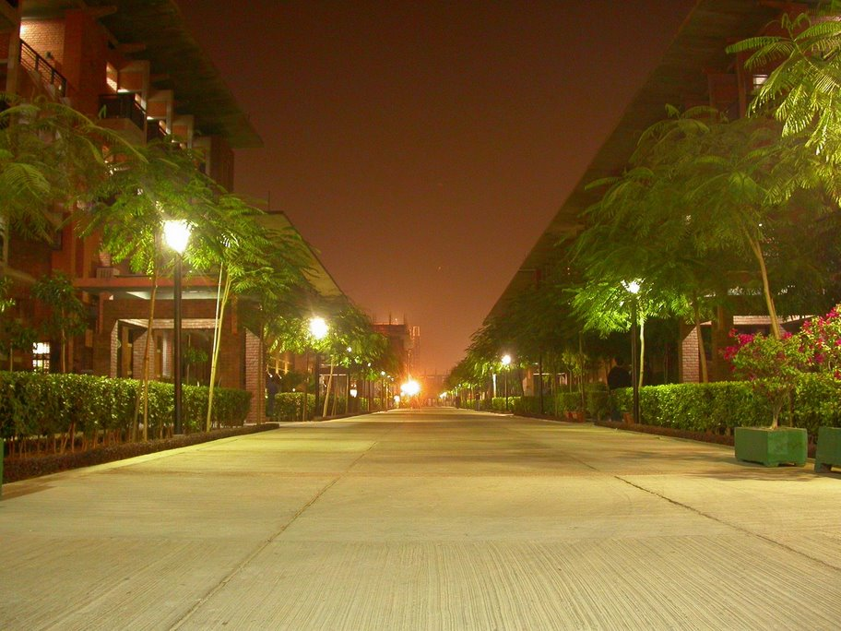
JIIT has been developed as a modern world class campus, with intellectually vibrant ambience in a serene and lush green environment. The state-of-the-art campus at a total project cost of Rs. 114 crores, with a total built up area of over 68340 sq. m comprising smart buildings with Internet, with Wi-Fi connectivity, including environmentally conditioned Academic Block, Annapurna (Mess), well-equipped modern laboratories, Learning Resource Centre, Faculty and student residences provides a pleasant and intellectually stimulating ambience for students in an eco-friendly environment. The details of the Infrastructure and available facilities are attached at Appendix-A.

ACADEMIC PROFILE

The Academic philosophy
Teaching
- Student centric learning
- Encouragement to self learning;
- Periodic review of curricula;
- Emphasis on creativity, design, innovation, laboratory, problem solving, projects, reasoning and communication skills and leadership qualities.
Research
- Research from undergraduate level;
- Faculty promotions based on R&D output;
- Emphasis on individual as well as group research;
- Undertaking project work in collaboration with the Industry.

Accreditation
Based on the report of team of National Board of Accreditation, AICTE, following programs of the University have been accredited:
Sr. No. Name of Program(s) Period of Validity
(w.e.f. 22.01.08)
1. CSE 5 Years
2. IT 5 Years
3. ECE 3 Years
4. Biotech 5 Years
Education System
- At JIIT, special emphasis has been placed on developing an environment highly conducive to building of a solid foundation of knowledge, personality development, confidence building, pursuit of excellence, self-discipline and enhancement of creativity through motivation and drive, which helps to produce professionals who are well trained for the rigors of professional and social life. All Students are encouraged to make life outside the classroom vibrant and enjoyable by engaging themselves in multiple extracurricular areas. Fun creativity, competition, distinction, establishing relationships with fellow students and others in the community and ultimately enhancing the value of their educational experience, is at the heart of all extracurricular activities.
- The academic year consists of basically two semesters. The education system is organized around credit system which ensures continuous evaluation of student’s performance and provides flexibility to choose courses of interest and to progress at an optimum pace suited to student’s ability or convenience. Each course is assigned certain number of credits depending upon the class contact hours. A specified number of credits and CGPA are to be completed satisfactorily in order to qualify for a degree. The medium of Instructions is English.

Programs Offered
UG Programs
In the pursuit of its objectives, the JIIT has gradually endeavored to increase the number and scope of Programs, leading to the degree of Bachelor of Technology in (i) Computer Science & Engineering, (ii) Information Technology, (iii) Electronics & Communication Engineering and (iv) Biotechnology.
The Programs of study emphasize strong conceptual understanding and practical skills in their respective areas of specialization. All students are provided with a sound foundation in basic sciences, coupled with courses in the Humanities and Social Sciences.
The education system lays great emphasis on continuous evaluation and transparency. By means of well designed tutorials and practicals, every effort is made to reinforce the concepts taught in the classroom and further enhancement of the learning is made possible by a unique educational concept called Project-Oriented Practice (POP) which consists of a minor project given to students from 2nd to 6th semesters. In the final year, a major project is assigned to students.
Industry internship after the 6th Semester is an integral part of the academic program leading to overall development of the student through exposure to practical skills in real life situations.
Education Methodology comprises multiple learning stages, specific Lectures, Self-study, Tutorials, Laboratory Work, Assignments, Projects, Research, Internships, Guest Lectures, Seminars, Continuous Evaluation, Examinations and Personality Development programs.

Dual Degree Programs
- 5 Year Dual Degree Program B. Tech-M. Tech (Bio Technology)
The Program has been offered for Biotechnology students admitted in Batch 2002, in their 7th Semester, as per merit drawn based CGPA. Similarly, the Program has also been offered for batches 2003, 2004 and 2005 students. Commencing from academic session 2006, the students for this program are being admitted in the 1st Semester itself. The program examines various areas of Biotechnology such as Protein Engineering, Bioprocess Technology, Cell Signaling, High Throughput Screening, Antibody Engineering & Manufacturing Processes and Clinical Data Base Management leading to both Bachelor’s as well as Master’s degrees having provided strong fundamentals and extensive training at the B. Tech level through various Core/Compulsory & elective subjects and extensive project and thesis work in the final year.

- 5 Year Dual Degree Program B. Tech-M. Tech (Computer Science Engineering)
Commencing from academic session 2008, the students for this Program are being admitted in the 1st Semester itself. The program examines various areas of computer science engineering such as Algorithms, Programming languages, Software Engineering, Operating Systems, Computer Architecture, Multimedia Systems, Intelligent Systems, Data Base Management, Computer Networks, Security, Web technologies, and Embedded systems leading to both bachelors as well as Master’s degrees. The program lays emphasis on student projects and research.

- 5 Year Dual Degree Program B. Tech-MBA (CSE/ECE)
The program has been offered for B Tech students admitted in Batch 2004 and 2005 in their 4th Semester, as per merit drawn based on the entrance test. The Program is also being offered for batches w.e.f. academic session 2006, in the 1st Semester itself. The program integrates coursework at the B.Tech level and at the MBA level through a Roadmap of ‘Bridge Courses in Management’ until the fourth year and regular courses in the fifth and final year being conducted exclusively at Jaypee Business School. Successful candidates get both the B. Tech (in respective branch of specialization) and the MBA degrees.

- 6 Year Dual Degree B. Pharm – M. Pharm Practice Program
With a vision to establish JIIT as a center of excellence within the ambit of Pharmacy, it has promulgated a Six Year Dual Degree B. Pharm – M. Pharm Practice program which commenced in June 2008. Pharmacy education with Practice Experience is rapidly gaining recognition and by making it an integral part of the undergraduate curriculum, we endeavor to bridge theory with application. It aims to produce self motivated and self reliant young pharmacists catering to the needs of industry, teaching and research by developing a convergence between divergent fields of pharmaceutical science, toxicology and computational technology (Bio informatics, chemo-informatics). Practice experience would strike an appropriate balance between knowing products, patient and disease states. At the end of the four year program, the students would be proficient in:
- Reviewing the proper drug prescription, dose, frequency, duration, distribution, storage and drug-disease interaction to ensure safe, effective and economical patient compliance.
- The two years of practice experience would make the students competent in the clinical care, communicating and collaborating with other healthcare professionals and healthcare organizations. The Dual degree would culminate with a commitment to the University, community and society.

Post Graduate Programs
JIIT has been successfully running M. Tech programs in Microelectronics Systems and Embedded Technology (MET), Computer Science and Engineering (CSE), Material Science and Engineering (MSE). Programs in M. Tech. in Electronics & Communication Engineering and MBA have been introduced w.e.f. Academic Session 2007-08. Further a M.Tech program in Applied and Computational Mathematics have also been started in the Academic Session 2009-10.
The objective of the M. Tech program is to prepare professionals with advanced knowledge of the respective field who can serve industry, R&D organizations and can take up an academic career, including further studies in a relevant Ph. D Program. The 2-year M. Tech programs are spread over four semesters.
All M. Tech Programs are designed to cover core/compulsory as well as elective subjects to advance knowledge, ability and skills of the students in their chosen area. Students can take the desired electives from the set of subjects offered from time to time to enable them to cater for their interest and to specialize in a particular field. Project and Thesis work are spread over the last two semesters, which provide ample opportunity to the student to carry out intensive work on a chosen topic resulting in an innovative and research oriented output. Seminars are included in the program to develop presentation skills in the students.

- M. Tech (Electronics and Communication Engineering)
The objectives of M.Tech (ECE) program is to equip students with advanced skills to design, develop, deploy and manage information and communication systems and their applications. The curriculum thrust includes:
  - Information Coding & Data Compression Techniques
  - Advanced Wireless and Mobile Communication
  - Advanced Satellite and Fiber Optic Communication
  - Multimedia Computing & Communication
  - Advanced Telecommunication Networks
  - Advanced Digital Signal Processing

- M. Tech (Microelectronic Systems & Embedded Technology)
The objectives of M.Tech (MET) program is to equip students with the ability to utilize tools and techniques to implement VLSI design on silicon and specialize in embedded system applications. The curriculum thrust includes:
  - Dynamic syllabi compatible to Semiconductor Industry Assoc. roadmap of VLSI
  - Convergence of design and technology
  - System-on-chip (SOC) design
  - Domain specific embedded system applications

- M. Tech (Computer Science & Engineering)
This Program offers a balanced emphasis on theoretical computer science, computer technology, software engineering, and applications of computing. The students have a choice of electives from electronics and communication engineering department also. The program provides advanced level education in areas like Algorithms and Data Structures, Software Engineering, Learning Sciences & Technology, High Performance Computer Architectures, Computer Networking, Complexities and Coding Theories, Information Security, Internet and Web Technologies, Computer Graphics, Image Processing, Information Systems, Data Ware Housing & Mining, Data Base Management, Operating Systems, Computational Models, Cognitive Science, Soft Computing and Human Computer Interaction.

- M. Tech (Materials Science and Engineering)
This is an interdisciplinary program aimed to impart advance level training in the specialized and emerging areas of Materials Science and Engineering and to fulfill the needs of industries and related R & D activities. It provides strong foundation in the fundamentals of structures, properties, processing and characterization of materials and will develop the ability and skill of students to design tailor made materials and fabricate devices for specific technological applications.
The thrust areas of this program are:
- Nanomaterials and nanotechnology
- Semiconductor microelectronic technology
- Optoelectronic and optical communication
- Polymers, ceramics and composites
- Computer aided modeling and simulation
- Materials for storage devices

- M. Tech in Applied and Computational Mathematics
The program is designed to train students in computational mathematics and theoretical computer science, so that they are well equipped to take up jobs in the software industry, research & development organizations. They can as well go for higher studies. The program enables them to learn computing, simulation and numerical techniques. A laboratory course devoted to the program enables the students to use softwares such as Mathematica, Matlab, Maple, Lindo, Lingo, SPSS, SAS etc.
- The MBA Program
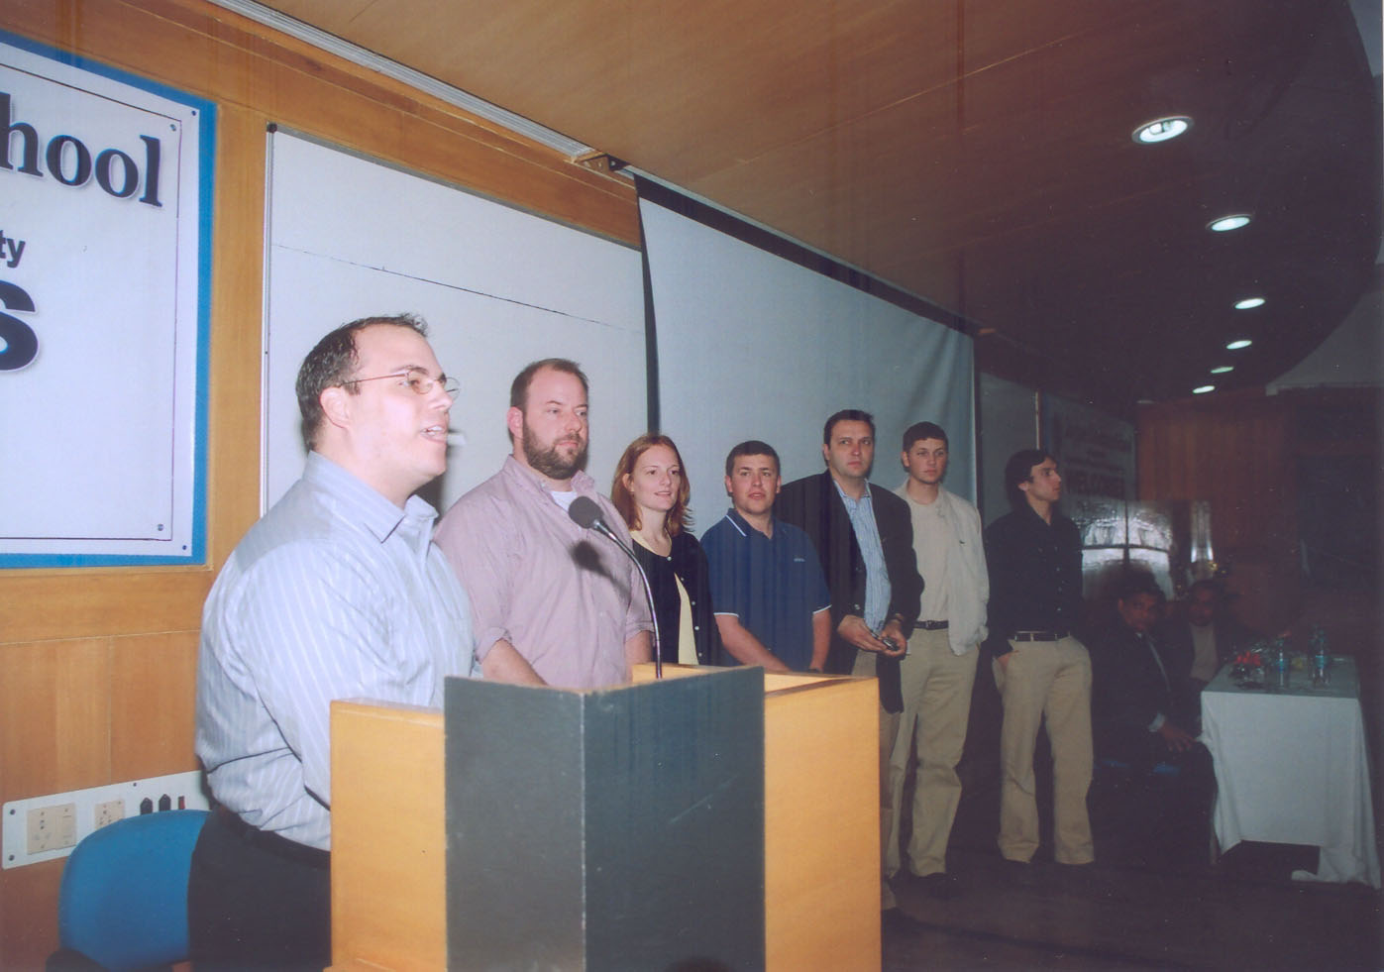
The Program of study emphasizes holistic learning coupled with various learning opportunities through specific interactions with faculty, peers and industry professionals. Self learning is encouraged through a methodology of structured reflection.
Industry/corporate involvement is a critical feature of the program of study. Students get to interact with professionals drawn from industry, government and academia, thus providing them with a 'practitioner's perspective'. Real-world business issues and applications are examined closely so that students can develop an ability to accordingly apply their learning outside a typical classroom setting. Overall, the program provides students with an enthusing opportunity to gain new perspectives on major global issues and on entrepreneurial activities.
The Class comprises a healthy mix of students with undergraduate specializations in areas such as engineering, arts, social sciences, finance, accounting, media and law.

Doctoral Programs (PhD)
The award of the PhD degree by the University is in recognition of high academic achievements demonstrated by independent research and application of knowledge to the solution of technical and scientific problems. Creative and productive inquiry is the basic requirement underlying research work. The academic program leading to the degree involves fulfilling course credit requirements, residential requirements and a thesis giving a critical account of the research carried out, in any of the areas listed below.

- Electronics & Communication Engineering
Telecommunications and Networking, Signal (including Speech and Image) Processing, Wireless and Mobile Communications, Optical Communications and Networks, Spread Spectrum, CDMA and Error Control Coding Techniques, Semiconductor Devices, Micro Electronics and VLSI, Neural Networks.

- Computer Science , Engineering and Information Technology
Algorithms, Computer Networks, Information Security, Data Ware Housing and Mining, Digital Image Processing, Soft Computing, Learning Sciences and Technology, Computer Graphics, Internet and Web Technologies.

- Biotechnology and Bio Informatics
Microbial Biotechnology, Protein Engineering, Proteomics, Genomics, Bioinformatics, Protein Modeling, Biosensors, Clinical Database Management Systems.

- Physics & Materials Science Engineering
Atomic and Molecular Collision Physics, Laser Physics, Solid State Ionics–Materials and Devices, Magnetite Materials, Advanced Perovskite Oxide Materials, Quantum Optics and Quantum Information Theory, Optical Fiber Sensors, Optoelectronic Materials and Optical Communications, Biophysics, Spectroscopy, Nanotechnology.

- Mathematics :
Applied Group Theoretic Techniques, Discrete Symmetries, Electromagnetics, Fluid Mechanics, Mathematical Modeling, Non-linear Partial Differential Equations, Wave Propagation, Wavelets and Differential Equations, Wavelets in Image Processing, Bio-statistics, Probability and Stochastic Modeling, Reliability Theory and Engineering Applications, Statistical Inference under Non-standard Conditions, Time Series Analysis and Forecasting.

- Management and Humanities
Management and Humanities programs focus in areas such as Corporate Finance, Project Management, Relationship Marketing & Services Management.

ACADEMIC DEPARTMENTS
All teaching & research programs at the University are carried out through the following departments:

Department of Computer Science & Engineering and Information Technology (CSE/IT)
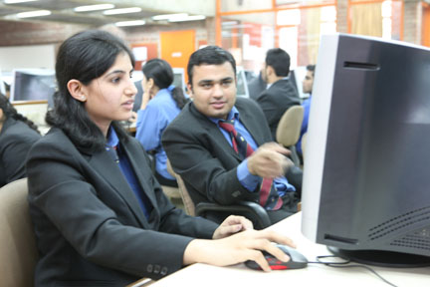
The Department runs with a vision to contextualize academic programs with social, ecological and economical environment. It continuously strives for excellence in education, research, and technological services to the society through an integrated curriculum. The department creates and sustains an environment in which students acquire knowledge and learn to apply it professionally with due consideration for ethical, ecological and economical issues. The Department aims to equip the students with the ability & skills to analyze, design and develop computer systems and their applications. The curriculum puts a balanced emphasis on theory, systems, and application.
The Department focuses on development and strengthening system thinking, problem solving, analysis, design, research, team work, communication skills, and readiness for lifelong learning. The courses run by department use mixed techniques of interactive lectures, guided case studies, literature surveys and project work that require team work and critical and creative thinking. It emphasizes on undergraduate as well as graduate research activities. The quality policy is to pursue global standards of excellence in all endeavors and to remain accountable through processes of self evaluation and continuous improvement. The department leverages the creative energies and enthusiasm of its senior students to enhance the learning of their juniors. All the courses are continuously upgraded, every year the previous syllabus is reviewed in the light of contemporary development in concerned subject area as well as its educational practices. With the result some content in every course is modified every year.
Nine students visited University of Florida for a semester. As part of cooperation with Infosys, approximately one hundred students had done final year project at their Mysore facility.

- Facilities including labs
Department puts a great emphasis on laboratory work. While laboratories are also used for developing skills to use and apply various concepts, tools and techniques, their main purpose is to develop the core technical as well as general professional competencies through experiential and collaborative learning. Main purpose of the laboratories is to develop the abilities to design and conduct experiments; collect, analyze and interpret data; work independently and also in teams; and also to improve reporting and communication skills.
This practical experience in the laboratory is intended to nurture the students' initiative, originality, creativity and spirit of inquiry and also to generate an appreciation of the nature of engineering design and scientific discovery. Through various active learning experiences in laboratories, students gain more insights into the field of study, develop ability to apply their knowledge to a greater extent, exhibit a greater level of understanding of course material and sharpen their problem solving skills.
The laboratories of department provide computational facility of approximately 400 computer nodes interconnected via LAN. This year following updations were done:
- 121 Multimedia PC were purchased, costing 31 lakhs of Configuration: HP Compaq (Core 2 Duo)
- Addition of 95 Licenses of Adobe Web Premium and 32 Licenses of Adobe Director, costing 21 lakhs.

- Faculty activities
Publications in International Journals
- Kaura, Varun , Yadav, Divakar, and Chaturvedi, Arun, “Threats to Mobile Agent & Possible Solutions”, International Journal on Cryptography and Security, vol. 1, no. 1, ISSN:0974-3359, pp. 22-28, July 2008.
- Mittal, Varun, Yadav, Divakar, and Chaturvedi, Arun, “Selective Data Stream Blocking Mechanism for Networks”, International Journal on Cryptography and Security, vol. 1, no. 1, ISSN:0974-3359, pp. 1-8, July 2008.
- Yadav, Divakar , Sharma, A. K., and Gupta, J.P., “Parallel Crawler Architecture and Web Page Change Detection Techniques”, WSEAS Transaction on Computers, vol 7, Issue. 7,pp. 929-941, ISSN: 1109-2750, July 2008.
- Yadav, Divakar, Sharma, A. K., and Gupta, J.P, “Topical Web Crawling Using Weighted Anchor Text and Web Page Change Detection Techniques”, WSEAS Transaction on Information Science and Applications, Issue 2, vol 6, ISSN:1790-0832, pp. 263-275, Jan 2009.
- Mittal, Varun, Yadav, Divakar, and Chaturvedi, Arun, “Incremental Indexed Backup Technique”, International Journal on Cryptography and Security, vol. 2, no. 1, ISSN: 0974-3359, pp. 41-48, January 2009.
- Saxena, Vikas, and Gupta, J.P., “A Novel Watermarking Scheme for JPEG Images”, “WSEAS Transaction on Signal Processing”, Issue 2, vol. 5, ISSN: 1790-5022, pp. 74- 84, February 2009.
Publications in National Journals
- Sharma, Raj Gaurav, and Saxena Vikas, "DWT-Based Watermarking for JPEG2000 Images" , The Icfai University Journal of Information Technology,vol. V, no. 2, ISSN: 1790-5022, pp. 28-36, June 2009
- Singh, Vipul, and Rathi, Manisha, "Performance Testing for the Bluetooth Positioning System" , The Icfai University Journal of Information Technology,vol. V, no. 2, ISSN: 1790-5022, pp. 56-65, June 2009.
Publications in International Conferences
- Gaur, Utkarsh, Jain, Amrita, and Goel, Sanjay, "Towards Real-Time Monocular Video-Based Avatar Animation", Proceedings of 4th International Symposium on Visual Computing (ISVC 2008), USA, December 2008.
- Asthana, Akshay, Dutta, Ranjan, Jain, Anshul, Gupta, Deepak, and Goel, Sanjay, ” Content Based Retrieval System for Archaeological Images”, The 2008 International Conference on Image Processing, Computer Vision, and Pattern Recognition (IPCV'08),July 2008.
- Mehta, Shikha, Gulati, Ankush, and Kalra, Ankit, ” A Hybrid Model for a Search Engine”, International Conference on Artificial Intelligence ICAI'08,Las Vegas, U.S.A, July 2008.
- Mehta, Shikha, and Anusha, K., “An Expert System for Health Care Specialists: A Fuzzy Data Mining Approach”, International Conference on Artificial Intelligence ICAI'08, Las Vegas, U.S.A, July 2008.
- Gupta, P., and Saxena, V., “ Multi-tier Virtual Machine Architecture: VM-on-VM (n,n-1) Implementation", Proceedings of The First International Conference on Contemporary Computing, pp 64-67, August 2008.
- Jain, C.K., Sharma, Anurag, Sharma, S. K., and Shukla, Y. P., “Frequency Distribution Analysis in 23S rRNA Sequences of Streptococcus & Helicobacter Sp. Using Mutual Information Theory”, World Congress on Engineering and Computer Science (WCECS 2008), Sanfrancisco, USA, pp. 21-23, October 2008.
- Goel, Sanjay, “Tutorial on Enriching the Culture of Software Engineering Education through Theories of Knowledge and Learning”, 22nd IEEE- CS Conference on Software Engineering Education and Training,Hyderabad, India, February 2009.
- Yadav, Divakar , Sharma, A. K., and Gupta, J.P., “Web Page Change detection”, Proceeding of the International Conference on Web Intelligence Systems (ICWIS09), Chennai, India, ISBN 978-81-8487-013-8, pp. 48-58, Jan 2009.
- Yadav, Divakar , Sharma, A. K., and Gupta, J.P., “Topical Web Crawling Using Weighted Anchor Text”, Proceeding of the International Conference on Web Intelligence Systems (ICWIS09), Chennai, India, ISBN 978-81-8487-013-8, pp.145-152, Jan 2009.
- Arora, Ritu, and Goel, Sanjay, "Software Engineering approach for teaching development of Scalable Enterprise Applications", 22nd IEEE- CS Conference on Software Engineering Education and Training, Hyderabad, India, February 2009.
Publications in National Conferences
- Dabas,Chetna, Kumar, Manish, and Gupta, J.P., "Problems in existing RFID Systems: User-Centered Design Methods", The 2nd National Conference on Next Generation Computing Technologies , Ghaziabad,U.P.,India, October 2008.
- Dabas,Chetna ,and Kumar, Manish, "Border Surveillance System using Visual Sensor Network and RFID: A Conceptual mapping approach", The 2nd National Conference on Next Generation Computing Technologies , Ghaziabad,U.P.,India, October 2008.
- Jain, Amrita, Gaur, Utkarsh, and Goel, Sanjay, “Adaptive System Estimation for Robust Feature Tracking”, National Seminar on Artificial Intelligence and Soft Computing, Gurgaon, India, 2008.
- Tyagi, Achin, and Goel, Sanjay, “Extension of UML profile to model Mobile Information systems”, National Seminar on Enterprise Information Systems, Jalandhar, India, 2008.
- Short Term Course Attended By Faculty
Refresher Courses
- Manish Thakur attended IUCEE" from 29th June(Monday) - 3rd July(Friday) on Algorithm, 2009 at Infosys, Mysore
- Hema.N attended IUCEE" from 22nd June - 26th june, 2009 at Infosys-Microprocessor, Mysore.
- Sandeep K Singh attended IUCEE Workshop on Data Structure held in Infosys Mysore June 22- 26, 2009.
Orientation Courses and Workshops
- Indu chawla, Prashant Kaushik, Parmeet kaur attended Workshop on IT Industry. Practices- Practitioners’ Approach in Data Warehousing, 9-10 February, 2009 by Accenture Services Pvt. Ltd.,Gurgaon.
- Sanjay Goel attended IUCEE Workshop on “Effective Teaching” by Richard Felder and Dr. Rebacca Brent at Infosys Mysor during 29th June- 1st July, 2009.
Department of Electronics & Communication Engineering (ECE)
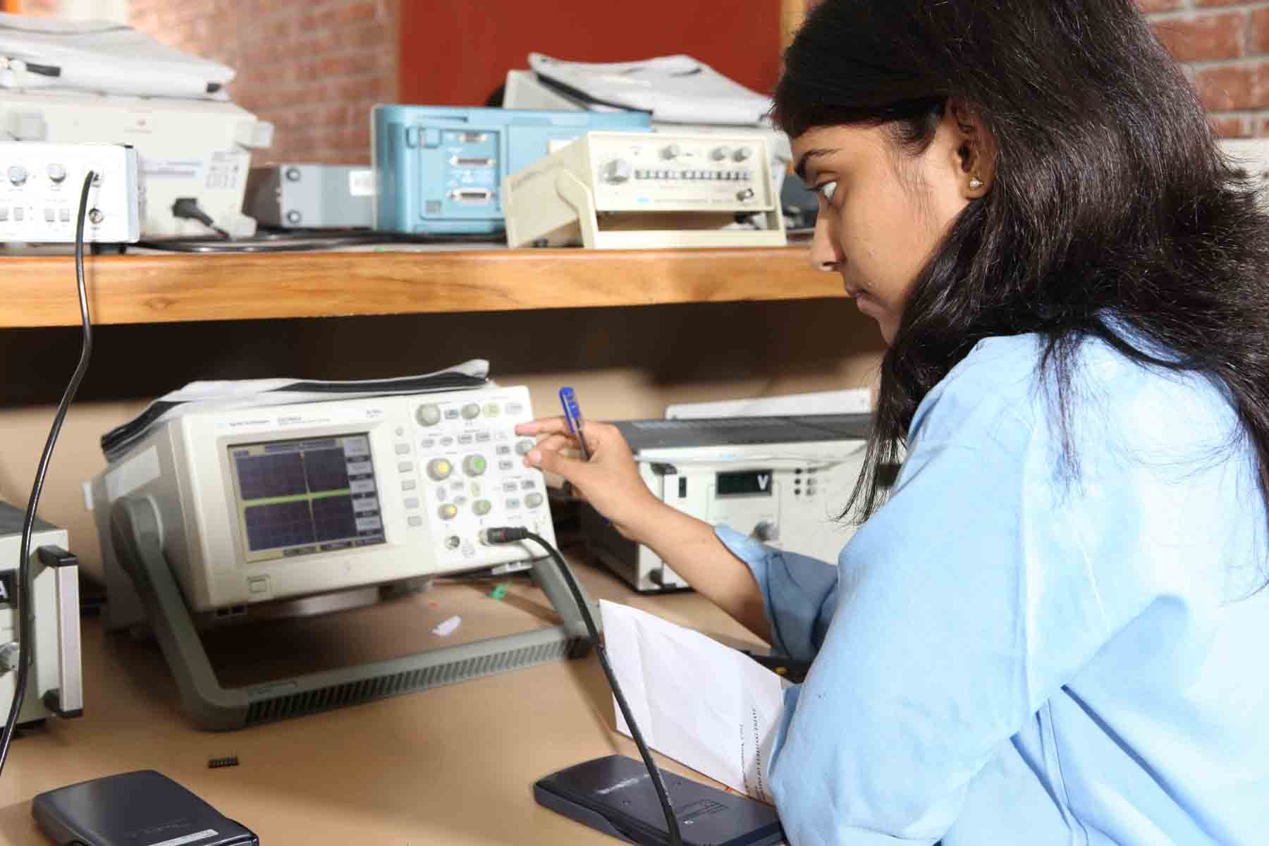
The department of electronics and communication engineering has come a long way and is at present running a full time UG program in Electronics and Communication engineering and two full time PG programs in Electronics and Communications engineering and Microelectronics Systems and Embedded Technology specializations besides PhD degree program in key areas of current technological importance.
In tune with the academic policy of the University in general and the ECE department in particular the curricula for the UG and PG programs have undergone a substantial revision which incorporates the recent trends in information and communication technology. Laboratory support for the lecture courses are provided by well-equipped laboratories of the department: Communication System laboratory, Control and Instrumentation laboratory, Microprocessor laboratory, Signal processing laboratory, VHDL/VLSI laboratory, Electrical Machines/Power Electronics laboratory, Electronic Devices laboratory, Advanced Communication laboratory and Project Laboratory.
All the laboratories are equipped with state of art instruments and software tools to enable the students to perform design oriented experiments and test their designs by computer simulations.
- Facilities Including Labs:
Laboratory support to programs is provided by the following well-equipped laboratories of the department:
- Communication System laboratory
- Control and Instrumentation laboratory
- Microprocessor laboratory
- Signal Processing laboratory
- VHDL/VLSI laboratory
- Electrical Machines/Power Electronics laboratory
- Electronic Devices laboratory
- Advanced Communication laboratory
- Project laboratory
All the laboratories are equipped with the state-of-art instruments and software tools to enable the students to perform design oriented experiments and test their designs by computer simulations.
- Faculty Activities:
Publications in International Journals
- N. Kalyanasundaram, A. Jindal, and A. Gupta, “H∞ Bounds for Quasi- Newton Adaptive Algorithm,” Signal Processing, vol. 89, pp. 2304-2309, May 2009.
- G. Kaur and N. Gupta, “Design and Performance Analysis pf 2.5Gbps OCDMA System by Using Newly Constructed MPSC Code Set for Metropolitan Area Network,” International Journal of Engineering Research and Industrial Applications (IJERIA), vol. 2, no. II, pp. 245-257, Feb 2009.
- G. Kaur and N. Gupta, “ Design and Performance Analysis of OCDMA System Using Newly Designed Multi wavelength Prime Sequence Codes at 1Gbps Bit rate,” Special issue on New Technologies Mobility and Security Volume( NTMS) - UBICC Journal, ISSN Online, pp. 1992-8424 Jan. 2009.
- N. Kalyansundaram and P. Palanisamy, “Target Detection by Adaptive Noise Cancellation,” Electronics Letters, vol. 44, pp. 1329- 1330,Oct 2008.
- Abhilekh Gupta, Vineet Khandelwal, M.C Srivastava and Abhinav Gupta, "Image Processing Methods for the restoration of Digitized Paintings" Thamasat Int. Journal of Science & Technology (ISSN: 0859-4074), Vol. 13, No.3, pp. 66-72, July 2008
Publications in International Conferences
- V.K. Dwivedi, P. Kumar, and G. Singh, “Performance Analysis of OFDM Communication over Correlated Nakagami Fading Channel,” in Progress In Electromagnetics Research Symposium (PIERS 2009), China, March 2009, pp. 1495-1498.
- P. Kumar, V.K. Dwivedi, G. Singh, and S. Bhooshan, “Input Impedance of Gap-coupled Circular Microstrip with Shorting Post”, in Progress in Electromagnetics Research Symposium (PIERS 2009), 23-27 March 2009, China. pp. 1634-1638.
- N. Chandra, A. Kumar, and A. B. Bhattacharyya, “Extended-Sakurai-Newton MOSFET Model for Ultra-Deep-Submicrometer CMOS Digital Design,” in 22nd International Conference on VLSI Design, New Delhi, 2009. pp 247-252.
- V. K. Dwivedi and G. Singh “Improved BER Analysis of OFDM Communication System on Correlated Nakagami Fading Channel,” in International Conference on Recent Advances in Microwave Theory and Applications, Nov. 2008. India, pp. 536-539.
- V. K. Dwivedi, P. Kumar, and G. Singh, “A Novel Blind Frequency Offset Estimation Method for OFDM Systems,” in International Conference on Recent Advances in Microwave Theory and Applications, Nov., 2008, India, pp. 668-675.
- P. Kumar, V.K. Dwivedi, G. Singh, S. Bhooshan, and D. S. Chauhan, “Miniaturization of Coupled Circular Microstrip Patch Antenna,” in International Conference on Recent Advances in Microwave Theory and Applications, Nov. 2008, India, pp. 489-491.
- K. Jain, A. Rustogi, and G. N. Babu, “Effective Capacitance calculation for Ground Planes,” in National conference on VLSI and Communication and Networks, Chennai, Sept. 2008, pp. 83-90
- S. D. Gupta, V. K. Sharma and A. Jain "Design of a Microstrip Patch TCAS Antenna," in XXIXth URSI General Assembly, Chicago, Illinois, USA, August 2008, pp. 9-16.
- V. K. Dwivedi and G. Singh, “An efficient BER analysis of OFDM systems with ICI conjugate cancellation method,” in Progress In Electromagnetic Research Symposium, Cambridge USA., July 2008, pp. 166-171.
- Gupta, Abhilekh., V. Khandelwal, Abhinav Gupta, and M. C. Srivastava, “Image Processing Methods for Restoration of digitized Paintings”, ThammasatInt. Journal of Science and Technology (ISSN: 0859-4074), Vol. 13, No. 3, July 2008, pp. 66-72.
- A. Jain, M. Agarwal, A. Gupta, and V. Khandelwal, “A Novel Approach to Video Matting using Automated Scribbling by Motion Analysis,” in IEEE Conference on Virtual Environments, Human-Computer Interfaces and Measurement Systems (VECIMS 2008), Istambul, Turkey, 14-16 July, 2008, pp. 25-30.
- A. Sharma, V. K. Dwivedi, and G. Singh, “THz Rectangular Patch Microstrip Antenna Design Using Photonic Crystal as Substrate,” in Progress In Electromagnetics Research Symposium (PIERS 2008), Cambridge USA, July 2008, pp. 161-166.
Short-term courses attended by faculty
Shamim Akhter & Rahul Kaushik attended a “Short term course on “Advanced DSP Design Technique" held at IIT Kharagpur from 1st June to 5th June , 2009

Department of Biotechnology
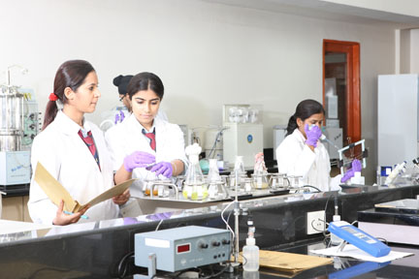
Biotechnology is radically changing the way issues related to human health, agriculture and environment. R&D ready workforce is a key domain within the growing biotechnology and pharmaceutical industry. JIIT in the year- 2002 set-up “Biotechnology Department” with mission to develop- quality human resource, and research infrastructure. The department offers study programs at both undergraduate and postgraduate levels. R&D is a part of the strategy to become an academic partner in biotechnology industry, which enhances academic effectiveness and gives direction to research. Public health in India is at cross-roads. Continuing with the focus on the knowledge economy, a pharmacy program has been launched leading to concurrent award of Bachelor’s in Pharmacy & Masters in Pharmacy Practice. The department is successful in carving a niche for itself on the national biotech education map. The department has active research programs in areas of broad significance such as human health, industrial biotechnology, and nano-biotechnologies supported by research grants worth over one-crore from national funding agencies. The department is proud to be consistently ranked one of the top biotechnology departments for quality education and research infrastructure by a leading Biotechnology magazine survey (Biospectrum, August 2009) amongst the private universities.
The curriculum is designed in such a way that they can face this challenge and build strong foundations in suitable mix of courses from life sciences, computer sciences, statistics/mathematics, physics, bioinformatics, systems biology, clinical trials/ health care IT and computer aided drug designing where teaching, practical training and research goes in parallel. A strong emphasis is laid upon the fundamental aspects so that students can understand and exploit the potential of biotechnology. Curricular teaching by regular faculty is enriched through integrating regular seminars by scientists from academia and industry.
The department has an active research program to impart research-driven training in subject areas of broad significance.
Thrust areas are of research are 1) Functional genomics & Proteomics, 2) Microbial Biotechnology, 3) Medicinal plants, 4) Nanobiotechnology and 5) Bioinformatics.
- Facilities including labs:
The department builds strong infrastructure to support modern research which is a vital component of the Biotechnology program. The biotechnology laboratories operate in more than 800 sq. m. of floor space accommodating a core facility with high-end instruments and dedicated curricular and research laboratories. There is regular up-grading of state-of-the-art equipments in both core and enabling technologies for maintaining research training standards in sync with industry requirements and attract private industry partnership. The laboratories are compliant with the bio-safety norms to carry out essential basic lab techniques, microbiological techniques, protein expression and purification, enzyme and electrophoresis studies, Immuno-technology studies, PCR and applications, cell culture technology, and bioinformatics tools and applications that constitute the methodological repertoire of biotechnology research. An exclusive laboratory exists to study molecular mechanisms of evolution of Drosophila malerkotliana. The plant tissue culture laboratory is equipped with automatic humidity and temperature control with required sterilizing equipments and incubation facility. The animal cell/tissue culture laboratory has dedicated incubator, laminar flow, microscopes etc. A dedicated functional genomics lab was added for studying functional genomics aspects of emerging viruses with Bio-safety level-2 (BSL-2) provision. The Department added Nanodrop spectrophotometer, Speedvac concentrator, dry heat bath, mini spin centrifuge and other small instruments.
- Faculty Activities:
Papers published in International Journals
- K. Shrey, A. Suchit, M. Nishant, R. Vibha, “RNA interference: Emerging diagnostics and therapeutics tool.” Biochemical and Biophysical Research Communication. vol. 386 pp 273–277, 2009.
- S.Gaur and N.Wadhwa, “Alkaline protease from senesced leaves of invasive weed Lantana camara”. African Journal of Biotechnology, vol. 7, no. 24, pp.4602–4608, 2008.
Papers published in National Journals
- S Mohanty, S. Saklani and M Mahajan. “In silico characterization of genetic homology in nuclear- encoded apicoplast-targeted genes between Plasmodium falciparum and P. vivax”. Ind. J Med.Res., vol. 129, no. 5, pp.520-524, 2009.
- S. Neha, R. Vibha, “The genetic blue print of heart development.” Research Journal of Biotechnology, vol. 4, no. 3, pp.68-71, 2009
- V. Rani and S. K. Goswami, “Isolation and characterization of developmentally regulated novel target site from embryonic chick heart”. African Journal of Biotechnology (In Press), 2009.
- A Shrivastava and S Srivastava. “Medicinal plants used worldwide for treating diabetes” Journal of tropical forestry, vol. 25, no.2 (in press), 2009.
Participations/Presentations/Publications in International conferences:
- K. Rawal and R. Ramaswamy, "ELAN: A protocol for analysis of mobile genetic elements", in Genomic impact of Eukrayotic Transposable Elements Asilomar, California, USA, 2009, pp 20-21.
- M. Nishika M, T. Kumar Siddhartho, S. Meha and S. Krishna Sundari, “Study Exploring the Bioremediating Abilities of Plant Growth Promoting Microbes”, Presented at the International Congress of Environmental Research (ICER-08), BITS – Pilani, Goa Campus, Goa, India., Dec. 18-20, 2008.
- S. Krishna Sundari, “Impact assessment study: Two decades of research on biofertilisers and sustainable alternatives - has the Indian farmer benefited”, in Proc. International Congress of Environmental Research (ICER-08), BITS – Pilani, Goa Campus, Goa, India, Dec.18-20, 2008.
- N. Gulati, K. Malhotra, L. K Oberoi , P. Gajwani, G. Mehta, D. Jain, I. P. Sarethy and R. Gabrani,. “Study of molecular diversity of Cycas sp. Using RAPD markers” in Proceedings of the International Congress of Environmental Research (ICER 08), BITS–Pilani, Goa Campus, Goa, India, Dec. 18-20, 2008, pp. 1093.
- N. Panjiar, P. Katiyar, R. Gabrani and I. P. Sarethy, “Isolation and Characterization of Streptomyces spp. from petrol contaminated sites” in Proceedings of the Ist international Society Biotechnology conference, Sikkim Manipal Institute of Technology, Gangtok, Sikkim, India, Dec. 28-30, 2008, pp. 19.
- C. K. Jain, A. Sharma, S. K. Sharma and Y P. Shukla, ”Frequency Distribution Analysis in 23S rRNA Sequences of Streptococcus & Helicobacter Sp. Using Mutual Information Theory”, in WCECS 2008 proceedings, San francisco, USA, Oct.22-24, 2008, pp 21-23.
- S. Jadhav, I. P. Sarethy and R. Gabrani, “Bioactivity of indigenous varieties of turmeric” in Proceedings of the 49th Annual Conference International symposium on Microbial Biotechnology: Diversity, Genomics and metagenomics, University of Delhi, North Campus, Delhi, India, Nov. 18-20, 2008, pp. 129.
- S. Sharma, A. Shrivastav, S. Agarwal, S. Pathak, A. Mathur, A. Singhal, S. K Sharma and S. Srivastava "A Stable and Small Response Time Biosensor Using Enzyme Nanoparticles" Nanotech Conclave 2009 - The Giant in Dwarfs at Hotel Taj Palace, Delhi 14-15 April 2009.
Participations/Presentations/Publications in International conferences:
- A Shrivastav and S Srivastava. “Designing safe sweetners for diabetic patients : An interaction analysis of sweet molecules”, Proceeding of national conference on Socio economic development- challenges before women scientists, technologists and engineers,NIT, Rourkela, Feb. 13-15, 2009, pp. 68-73.
- S Kalra., S Gupta., A Kharkia., S Naik., A Shrivastav., N Goswami. and S Srivastava “Amperometric glucose biosensor with reduced response time”, Proceeding of national conference on Socio economic development- challenges before women scientists, technologists and engineers: NIT, Rourkela, Feb. 13-15, 2009, pp.238-243.
- S Krishna Sundari, “Progressive use of molecular techniques in ectomycorrhizal diversity studies”, in Proc. National Conference on Biodiversity: Present Status and Future Challenges, University of Kashmir, Srinagar, Jammu & Kashmir, India, 2009.
- R.K.Tiwari, S. Chanda, B. De and I.P, Sarethy, “Ethno botanical plants used by people of Kadipur, Faizabad, UP, India” in National Conference on Recent Trends in Biodiversity and researches organized by Assam University, Assam, March 16-18, 2009, pp.33.
- M. Raina, A. Tikku, and S. Mohanty “Diversity of Drosophila species in India” National conference on Biodiversity and Agribiotechnology, JIITU, Noida , 2009, April, pp. 56
- GB. Singh, S. Gupta, SK Sharma and N. Gupta “Screening of microorganisms from soil utilizing dibenzothiophene and Carbazole” in National conference on Potentials of Biotechnology and Microbiology in India . Institute of Applied Medicines and Research, Duhai, Ghaziabad, India, Jan. 3-4, 2009.
- N. Panjiar, S. Rastogi and R, Gabrani, “Revising the forgotten life- strategy to cease the growth of Alzheimer’s disease” in Proceedings of the National conference on Drug discovery and development, University of Delhi, South Campus, New Delhi, India, Jan. 21-23, 2009, pp.61
- S. Jadhav, V. Rani, I. P. Sarethy and R. Gabrani, “Antimicrobial activity of Curcuma caesia (black turmeric) and Coleus barbatus (patharchur) in aqueous extract” in Proceedings of the DBT sponsored one day National conference on Biodiversity and Agribiotechnology, JIITU, NOIDA, India, April 25, 2009, pp. 102.
- S. Pandey, S. Gaur, N. Wadhwa and N. Vemuri “Wheat glutenin as biolymer: Potential in biodegradable food packaging and in cell culture technology” in “National conference on potentials of biotechnology and microbiology, IAMR, 2009. January, 3-4, 2009
- D. Khaira, N. Agnihotri, S. Burugupalli, S. Sharma, and N. Vemuri, “ Induction of heat shock protein 70 in Buccal epithelial cells” in National Conference Biogenesis II: future challenges and oppurtunities, Indian Institute of Learning and Management, Ghaziabad, India, February, 27-28, 2009.
- P. Gupta, K. Singh, A. Kamra, and N. Vemuri, “ Cytosolic glutathione S-transferase (GST) profiling in patients suffering from squamous cell carcinoma (SCC) of the buccal mucosa and lungs ” in National Conference Biogenesis II: future challenges and oppurtunities, Indian Institute of Learning and Management, Ghaziabad, India, February, 27-28, 2009.
- M. Choubey, K. Tiwari, D. Gupta & Vibha Rani. “Induction of biotic stress in Arabidopsis thaliana to find out potential defense protein target site.” In National Seminar and workshop on metabolic Network and drug designing Banaras Hindu University, Varanasi, Oct. 2008, pp.25
- A. Parihaar, H. Gupta, N. Singh, A. Shrivastav and S. Srivastava “Novel Drug Molecule overcoming T315I mutation in chronic myeloid leukemia” in National conference on Bioinformatics and Computational Technologies BioCT MBM college Jodhpur Mar. 21-22, 2009, pp. 68 (This poster received Ist prize)
- N. Janmeja, N. Agarwal, I. Chopra, A. Shrivastav and S. Srivastava “Mutational Analysis of crucial residues of human sweet taste receptor eliciting sweet response”, in National conference on Bioinformatics and Computational Technologies BioCT MBM college Jodhpur, India, Mar. 21-22, 2009, pp. 5 (This poster received IIIrd prize)
- S. Prakash, P. Gupta, S. Kumar, S. Sharma and S. Srivastava “A Nanoparticle Based Glucose Biosensor” at National conference on "Potentials of Biotechnology and Microbiology in India" Institute of Applied Medicines and Research (IAMR) Ghaziabad . January, 3 – 4, 2009. (This poster received II prize)
- A. Shrivastav and S. Srivastava “Designing safe sweetners”, National Conference on. Drug Discovery & Development, University of Delhi, South Campus, New Delhi, India, Jan. 21-23, 2009, pp.41
- H. Gupta, A. Parihaar, N. Singh, N. Vemuri and S. Srivastava “Designing drugs to Chronic Myeloid Leukemia surmounting mutational resistance to known Drugs” National Conference on Drug Discovery & Development, University of Delhi, South Campus, New Delhi, India, Jan. 21-23, 2009, pp.43

Department of Physics and Material Science and Engineering
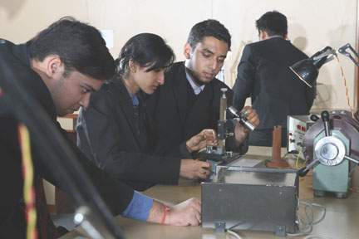
The Department of Physics and Material Science and Engineering offers various interdisciplinary courses and projects at the undergraduate and postgraduate level. The department also runs an M.Tech Program on Material Science and Engineering. In the academic year 2008-09, seven students have obtained M. Tech degree in Material Science and Engineering. All faculty members of the department are active in research and the research areas of the faculty includes: Laser Physics, Atomic and Molecular Collision Physics, Solid State Ionics, Materials and Devices, Advanced Perovskite Oxide Materials, Quantum Optics and Quantum Information Theory, Optical Fiber Sensors, Optical communications, Biophysics, Spectroscopy and Nanotechnology. The faculty of the department have obtained externally funded research project and have established some research collaborations with corresponding departments in various other universities in Germany, Canada, Argentina and India. In near future the department wishes to extend the collaborative work and establish industry-institute linkage.

- Facilities including Labs:
A state of art material science laboratory has been established in the department. The major facilities in this laboratory include: FTIR Spectrophotometer, UV-VIS spectrophotometer, Photoluminescence Spectrometer, Vacuum-Coating unit, Optical microscope for microstructure studies, Hardness testing machine, Hydraulic press, Keithley digital multi-meter, LCR meter, Polishing machine, Laser sources of different powers etc. Apart from this, the department has two undergraduate laboratories, which contain: Hall effect setup, Four probe setup, dielectric constant measurement device, Magnetostriction and Magnetoresistance measurement devices, Fiber optic kit and various other (optical and electrical) instruments for under graduate experiments. In recent past department has also enriched in collection of useful journals and software related to the research interest of the faculty. Mathematica 5.2, hard copy of Phys. Rev. Lett and Nature Materials has been added recently.

- Faculty activities to include
Papers published in International Journals:
- S. P. Purohit and K. C. Mathur “Resonant laser assisted elastic scattering of electrons by lithium and sodium atoms” Eur. Phys. J. D, vol. 53, pp.173-177,2009
- A. Verma and A. Pathak,"Reduction of quantum phase fluctuations in intermediate states", Physics Letters A, vol 373, pp 1421-1428, 2009.
- N. K. Sharma and A. Pathak “Bosonic Channel Capacity of a Nonlinear Dispersive Optical Fiber”, Applied Mathematics and Information Sciences, vol. 3(2), pp. 151-158, 2009.
- P. Gupta and A. Pathak “Minimum total noise is a measure of higher order squeezing” Optik, International Journal for Light and Electron Optics, In Press.
- V. Sajal and V. K. Tripathi, “Large amplitude lower hybrid wave driven by laser and its effect on electron acceleration in magnetic plasma channel”, Optics Communication, 281(13), pp 3542-3546, 2008.
- J Chandra, R Kumar and B.R.K.Gupta, “Temperature dependence of bulk modulus and second order elastic constants of Minerals”, High Pressure and High temperature, 37, pp 335-359, 2008.
- N. Kumar, S. Chakravorti and P. Chowdhury, “Experimental Investigation by UV-VIS and IR Spectroscopy to Reveal Electronic and Vibrational Properties of Pyrrole-2-Carboxyldehyde: a Theoretical Approach”, Journal of Molecular Structure, vol.891, pp. 351-356, 2008.
- K P Singh, V Sajal and D N Gupta, “Quasi-monoenergetic GeV electrons from the interaction of two laser pulses with a gas”, Laser & Particle Beams, 26, pp. 597-604, 2008.

Papers in International/ National Conference:
- P Kumar, Vikash Singh, Ravikant Prasad, H.K. Singh and R. K. Dwivedi,“Magneto-electrical studies in LSMO-BTO bulk and nano composites” ICMAT & IUMRS-ICA, June 28-July 3, 2009 Singapore. (Presented as oral presentation)
- Om Parkash, Surendra Baboo, Ravi Kumar and R.K.Dwivedi, “Ferroelectric to Paraelectric Transitions in the system Ba1-xLaxTi1-xCrxO3” ICMAT & IUMRS-ICA, June 28-July 3, 2009, Singapore. (Presented as poster presentation)
- A. Gupta, P. Kumar, Ravikant Prasad, H. K. Singh, and R. K. Dwivedi,“Compositional tunning of magneto-transport properties in Pb doped NdMnO3” International Conference on Transport & Optical Properties of Nanomaterials, January 5-8, 2009, University of Allahabad, Allahabad 211002, India.
- A Pathak and A. Verma, " Recent developments in the study of higher order nonclassical states" Conference on Laser Applications in Basic and Applied Science(CLBAS-2009), Visva Bharati, Santiniketan, Feb 2009.
- A. Banerjee and A. Pathak, “Probabilistic fault models for quantum circuits”, International Workshop on Quantum Phase Transition and Dynamics: Quenching, Annealing and Quantum Computation, SINP, Kolkata, India (2009).
- A. Banerjee and A. Pathak, “Quantum circuits for use in simulations of time-independent hamiltonians” , International Workshop on Quantum Phase Transition and Dynamics: Quenching, Annealing and Quantum Computation, SINP, Kolkata, India (2009).
- A. Banerjee and A. Pathak, “Optically implementable designs of reversible sequential devices”, Conference on laser applications in basic and in applied sciences, Vishwabharati, India (2009).

Participation of faculty members in seminars, symposiums, conferences
Dr. A Pathak
- Delivered 9 invited talks at Summer School on, “Physics of Rotation” organized by Porrna Prajna Institute of Scientific Research, Bangalore, during June 15-24, 2009.
- International conference CLBAS-2009, Visva-Bharati, Santiniketan, India, during February 14-17, 2009
- Delivered invited talk on Quantum cryptography at Two-Days Workshop on “Quantum Mechanics: Theory and Application”, Deen Dayal Upadhyaya College, University of Delhi, November 21-22, 2008
Dr. R. K. Dwivedi
- International conference on Materials for Advanced Technologies 2009 (ICMAT-2009 and ICA-IUMRS-2009) by NUS Singapore and MRS Singapore, June 28 – July 3, 2009.
Mr. Amit Verma
- International symposium “Optics and Photonics 2008” organized by SPIE USA at San Diego, California, 14-18 August 2008.
- Workshop on “Quantum Mechanics: Theory and Applications”, DDU College, University of Delhi, New Delhi, Nov.21-22, 2008.
Ms. Anindita Banerjee (PhD Student)
- International conference CLBAS-2009, Visva-Bharati, Santiniketan, India, during February 14-17, 2009
- International Workshop on Quantum Phase Transition and Dynamics: Quenching, Annealing and Quantum Computation, SINP, Kolkata, India (2009).
- Indo-US Advanced School on Quantum and Nano Computing Systems and Applications (QANSAS-2008) at Dayalbagh Educational Institute (Deemed University), Agra, December 11-14, 2008
- Two-Days Workshop On “Quantum Mechanics: Theory and Application” at Deen Dayal Upadhyaya College, University of Delhi, November 21-22, 2008.

Department of Mathematics
Department of Mathematics was created from the very inception mainly to cater to the basic needs of the various B.Tech programs of the Institute. It started with a very modest beginning as a single faculty member having only a handful of courses. The role and usage of mathematics have increased manifold in the last decade with the setting in of information revolution which has resulted in substantial changes in several other disciplines also. This has put additional expectations on mathematics from the point of view of teaching, research and applications. Skills in computational mathematics are needed more than ever before. Keeping this in mind a number of new courses (core as well as elective) have been designed and introduced at graduate and post graduate level. Presently more than fifteen courses are being taught at B.Tech level and around twenty courses at M.Tech Level.
The thrust areas of the department are:
- Wavelets and their Applications to Approximation of the Functions and Image Compression.
- Numerical Analysis, Software Development, Computer Graphics & Animation
- Coding Theory and Information theory
- Functional Analysis, Categorical Fuzzy Topology and its Applications
- Operations Research and Statistics
- Elasticity, Plasticity and Creep, MHD and CFD

- Facilities in the department:
Department is extensively availing the facilities provided by the Learning Resource Centre (LRC) of the University. Further department is sharing the labs with CS/IT for the laboratory work of M. Tech. students.
- Faculty activities to include
Papers published in International Journals:
- Bani Singh, Anuj Bhardwaj and Rashid Ali, "A wavelet method for solving singular integral equation of MHD", Applied Mathematics & Computation 214, 271-279, 2009.
- Bhagwati Prasad, B. Singh & R. Sahni, “Some approximate fixed point theorems”, Int. J. Math. Anal., Vol.3, No. 5, 203 – 210, 2009.
- Lokendra Kumar, “Finite element analysis of combined heat and mass transfer in hydromagnetic micropolar flow along a stretching sheet”, Computational Materials Science, In Press, Corrected Proof, Available online 19 May 2009.
- Neetu Gupta, G.D.Mishra & Alka Choubey, “Performance analysis of an M/M/1/K queue with non-preemptive priority", International Journal of Mathematical Sciences and Engineering Applications, Vol 3, No. 2,pp 285-292, 2009.
- S. L. Singh, Bhagwati Prasad & A. Kumar, “Fractals via iterated functions and multifunctions”, Chaos, Solitons & Fractals, Vol. 39, No. 3, 1224-123, 2009.
- Alka Choubey and Ravi KM, "Intuitionistic Fuzzy Automata and Intuitionistic Fuzzy Regular Expressions", J. Appl. Math. & Informatics, Vol. 27, No. 1-2, pp.409-417, 2009.
- P.C. Jha, Deepali Gupta, Bo Yang, P.K. Kapur , “Optimal Testing-Resource Allocation During Module Testing Considering Cost, Testing Effort and Reliability”, Computers & Industrial Engineering, Article in Press, 2009.
- A. K. Aggarwal and K. Prakash, "Effect of suspended particles and rotation on thermal instability of ferrofluids” , International Journal of Applied Mechanics and Engineering, Poland, Vol.14, No.1, pp. 55-66, 2009.
- Sanjeev Sharma and Manoj Sahni, "Elastic-Plastic Transition of Transversely Isotropic Thin Rotating Disc, Contemporary Engineering Sciences, Vol. 2, no. 9, pp. 433 - 440, 2009.
- Vivek Kumar and Mani Mehra, “Wavelet optimized finite difference method using interpolating wavelets for self adjoint singularly perturbed problems”, J. Comp. & Appl. Math., 230, 803-812, 2009.
- Sanjeev Sharma and Manoj Sahni, “Creep Analysis of Thin Rotating Disc under Plane Stress with no Edge Load”, WSEAS Transactions on Applied and Theoretical Mechanics, Vol. 3, Issue 8, pp. 725-738, August 2008.
- Sanjeev Sharma and Manoj Sahni, “Creep transition of transversely isotropic thick-walled rotating cylinder”, Advances in Theoretical and Applied Mechanics, Vol. 1, no. 7, pp. 315-325, 2008.
Papers published in National Journals:
- Sanjeev Sharma and Manoj Sahni, “Elastic-Plastic Transition of Transversely Isotropic Thick-Walled Rotating Cylinder under Internal Pressure”, Defence Science Journal, Vol. 59, no. 3., May 2009.
- Sanjeev Sharma, “Thermo Creep Transition in Non-homogeneous Thick-walled Rotating Cylinders”, Defence Science Journal, Vol. 59, No. 1, January 2009.
- Bhu Dev Sharma, "Partitioned Product of Matrices and Construction of Efficient Product Codes", Jr. of Comb. Information & System Sciences, 33, 437-448, 2008.
- Neetu Gupta, G.D.Mishra & Alka Choubey, "Performance analysis of an queueing model M/M/c/N with balking and reneging", International Journal of Computer, Mathematical Sciences and Applications, Vol 2, No. 4, pp 355-339,October-December 2008.

Participation of the faculty in International Conferences
- Sanjeev Sharma and Manoj Sahni, “Creep transition of transversely isotropic thin rotating disc”, 6th IASME/WSEAS International Conference on Fluid Mechanics and Aerodynamics (FMA ’08), Greece, Aug. 20-22, pp. 72-77, 2008.
- Bhu Dev Sharma, “Product of matrices for efficient codes”, International Conference on Discrete Mathematics ICDM-2008, Mysore University, Mysore, June 06-10, 2008.
Participation of the faculty in National Conferences
- Bhu Dev Sharma & Anurag Biyani, "Implementation and Comparative Study of Time Efficiency of various QKD Protocols in 802.11i networks", Proceedings of UGC Sponsored National Conference on ‘Social Development Under the Aegis of Operations Research), March 21-22, 2009.
- A. K. Aggarwal and Suman Makhija, “Thermal stability of couple-stress fluid in presence of magnetic field and rotation” National Conference on Biomechanics organized by Indian Society of Biomechanics at Department of Mathematics, Indian Institute of Technology Roorkee, March, 2009.
- Bhagwati Prasad, Bani Singh and Ritu Sahni, "Modified three step Noor iterative scheme for family of maps in Banach spaces", 24th National Conference on Analysis and its Applications (AA-BHU 2009), Banaras Hindu University, Varanasi , March 19-21, 2009.
- Bhagwati Prasad, Bani Singh and Ritu Sahni, “A common fixed point theorem for hybrid maps with an integral type condition”, 24th Annual Conference of the Mathematical Society, Banaras Hindu University, Varanasi, December 30-31, 2008.
- Bhagwati Prasad, “A stability result for set valued operators”, 74th Annual Conference of Indian Mathematical Society held at Department of Mathematics, University of Allahabad, Allahabad, December, 27-30, 2008.
- Neetu Gupta, G. D.Mishra, and Alka Choubey , "Performance analysis of queue-ing model M/M/I/N with balking and reneging", Accepted for publication in proceedings of National Conference on “Management Science and Practice MSP 2008”, at Indian Institute of Management, Ahmedabad, India, 2008.
- Manoj Sahni, “Traffic Noise and Its Control Measures”, 24th Annual Conference of the Mathematical Society- BHU, Varanasi, Dec.30-31, 2008.
- Deepali Gupta, Pre-ICM International Convention on Mathematical Sciences, Department of Mathematics, University of Delhi, December 18-20, 2008.
Participation in academic activities other than teaching and research
- Prof. Bani Singh presided over a session in the conference on “Applied Science and its Technology for Innovation Management”, Krishna Institute of Engineering & Technology, Ghaziabad, Aug 9, 2009.
- Prof. Bani Singh was invited to the Study Group Meeting on Industrial Problems (SBMIP) jointly organized by Industrial Mathematics Group, IIT Bombay and Dept. of Mathematics, IIT Roorkee from March 16 – 21, 2009. The problems from industry were posed and discussed.
- Dr. Lokendra Kumar has participated in Study Group Meeting on Industrial Problems (SBMIP) jointly organized by Industrial Mathematics Group, IIT Bombay and Dept. of Mathematics, IIT Roorkee from March 16 – 21, 2009.
- Dr A. K. Aggarwal has participated in a Short Term Course on “Recent Advances in Optimization Techniques and Their Applications” organized by Department of Mathematics, Indian Institute of Technology Roorkee, April 20-24, 2009.
- Dr A. K. Aggarwal has participated in a An AICTE Sponsored QIP Short Term Course on “Mathematical Computations Using Software Tools” organized by Department of Mathematics, Indian Institute of Technology Roorkee, July 1-5, 2008.

Department of Professional Development
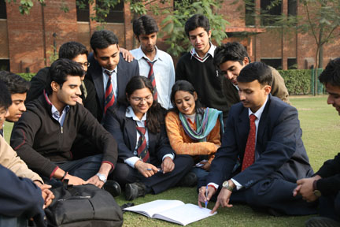
The department of Professional Development is a source of change-facilitators who serve to complement the existing and emerging educational programs the institutions by imparting professional and behavioral competencies and, thereby, transforming the students to become the New-age, Innovating, Competitive and Enterprising leaders in their chosen professions of service and technology. This department serves as a ‘Center of Excellence’ dedicated to the dissemination of professional and behavioral knowledge pertaining to Communication skills, Interpersonal skills and Managerial skills among JIIT students The Department was set up with the intention of producing well-rounded engineers, not only having good technological skills but also with the ability to interact with different organs of an organization.
Professional Development (PD) Department commits to make the following deliverables in respect of Teaching, Research and Service to family of institutions:
Teaching
- To improve the quantitative, communication and interpersonal skills of students.
- To provide high-quality decision-making education in all area of professional and behavioral development.
- To improve the effectiveness and quality of teaching of the faculty.
- To encourage the faculty to place greater emphasis on motivating and counseling students and to participate in students’ organizations and activities.
- To update, enrich and present the course content and keep them increasingly relevant and action-oriented.
- To design customized professional courses to complement and enhance the niche areas of engineering and technologies.
- To develop, sponsor, and conduct executive education.
Research
- To improve the research atmosphere and support to the department.
- To encourage faculty and students to research and present at least one research output every year at professional meetings.
- To help identify joint research projects and topics and to encourage faculty members towards interdisciplinary projects.
- To increase the approach and acquisition of research grants and sponsorships.

Service
- To encourage faculty and students to relate usefully to institutions and wider community via active participation in selected activities.
- To encourage faculty members to work with Departmental and University committees and programs.
- To encourage faculty and students to serve the local, national and professional organizations.
- To encourage faculty and students to apply for and participate in service oriented grants and sponsorships.

- Facilities including labs
The department is setting up a 30 computer language lab. The department has also purchased the software for the language system (Clarity digital multimedia language system from U.K.) consisting of:
- Sky Pronunciation Suite
- Connected Speech
- Tense Buster Compilation
- 31 Headphones
The department also has SPSS 16.0 software with SPSS Base and four add-on modules: SPSS Conjoint, SPSS Neural Networks, SPSS Regression Models, SPSS Trends.

- Faculty Activities to include:
Presentations and Publications
- M. Mani and B. Arora, “Study of Parameters of Ranking of Commercial Banks with regard to Banking Regulatory Guidelines”, Global Journal of Business Management, vol.3, no.1, 93-101, 2009.
- A. Sharma, A. Gupta, and D. Khilnani, “Identification and correlation of software project risks for excelling in IT industry”, Focus- The International Journal of Management Digest, vol. 5, no. 1&2, pp. 42-50, 2009.
- M.R. Behera and V. Jain, “Promoting Competitiveness of Indian Pharmaceutical Industry through R&D Investment”, Conference on Global Competition & Competitiveness of Indian Corporate, Kozhikode, 2009.
- A. Gupta and R. Agrawal, “Significance of factors causing time delays in BOT projects in India”, International Conference on Decision Sciences in Global Enterprise Management, Mumbai, 2009, pp. 573-581.
- S. Bhattacharjee, “Child labour in India: a health and human rights perspective”, 6th International conference on Health, Equity and Human Rights, Tamil Nadu, 2009, pp. 26-27.
- S. Bhattacharjee, “Health Education and Quality of Life: The Santal Community in Bengal”. 2nd National Conference on Innovations in Management Practices, New Delhi, 2009, pp. 55.
- S. Dev, “Ethics and Business Intelligence”, 2nd National Conference on Innovations in Management Practices, New Delhi, 2009, pp. 56.
- S. Dev and A. Gupta, “Influence of emotional intelligence in organizational creativity” 3rd National Conference on Service Management, Jagadhri, 2009, pp. 3.
- S. Sharma and A. Gupta, “Leadership in the curricula of business schools” 3rd National Conference on Service Management, Jagadhri, 2009, pp. 29.
- S. Sengupta and A. Gupta “Gold rush of Indian BPO’s in 21’st century: changing trends and challenges”, 3rd National Conference on Service Management, Jagadhri, 2009, pp. 24.
- S. Bhattacharjee, “Poverty and human development: The Santal Community in Bengal”, 3rd National Conference on Service Management, Jagadhri, 2009, pp. 17.
- A. Sharma, A. Gupta, and D. Khilnani, “Identification and ranking of software project risks,” Asia Pacific Business Review, vol. 4, no. 2, pp. 116-122, 2008.
- A. Sharma, A. Gupta, and D. Khilnani, “Identification and correlation of software project risks for excelling in IT industry”, International Conference on Doing Business in India, Bangalore, 2008.
- S. Sengupta, A. Gupta and V. Sandhir, “Relationships among selected demographic factors and employee satisfaction level in Indian BPOs”, International Conference on Doing Business in India, Bangalore, 2008.
- Gupta, S.S., Gupta, A. (2008), “Vicious Circle of Attrition in the BPO Industry”, in IUP Series (reference book) on Voice Based BPOs: HRM Practices, by Arpita Dasgupta, ISBN: 978-81-314-1597-9.
- S. Bhattacharjee, “Information and Communication technology in Rural Development”. National Conference on Next Generation Computing Technologies, Ghaziabad, 2008.
- S. Dev, “Motivation: from the perspective of the Bhagwad Geeta”, Review of Business and Technology Research, vol.1, 1-7, 2008.
- S. Bhattacharjee, “Tourism and the Commonwealth Games in 2010”, Review of Business and Technology Research, vol. 1, No. 1, 1-5, 2008.

Conferences/ Workshops/ FDPS Attended
- S. Dev and S. Bhattacharjee attended 2nd National Conference on Innovations in Management Practices held by Apeejay School of Management, New Delhi in June 2009.
- S. Sengupta attended a 5 day workshop on Statistical Methods organized by Apeejay Institute of Management Dwarka, Delhi, 25-29 May 2009.
- S. Dev, S. Bhattacharjee, S. Sharma, S. Sengupta attended 3rd National Conference on Service Management organized by Maharaja Agrasen Institute of Management and Technology on 9th May, 2009 at Jagadhri.
- A. Gupta and M. R. Behera attended a two day ‘Training the Trainer’ Program on Logistics and Transport Management organized by JBS, Noida and CILT, International, 24-25 April 2009.
- S.Bhattacharjee attended 6th International conference on Health, Equity and Human Rights organized by School of Social Sciences and International studies, Pondicherry University, Tamil Nadu UNICEF and UNFPA at TamilNadu in March 2009.
- S. Sengupta attended International Conference on Doing Business in India organized by IIFM Bangalore in December 2008.
- S.Bhattacharjee attended National Conference on Next Generation Computing Technologies organized by ITS Management and IT Institute, Ghaziabad in October 2008.
- S. Dev, and S. Bhattacharjee, attended an International Conference on “Global Issues in Business & Technology”, Organized by National Institute of Financial Management, Faridabad in collaboration with DBMA, University of Maryland USA, July 2008.
- S. Dev delivered invited lecture on “Emotional Intelligence” in University Science Instrumentation Centre, Kurukshetra University, Kurukshetra, March 2009.
- S. S. Gupta organized workshop on “Soft Skills” in University Science Instrumentation Centre, Kurukshetra University, Kurukshetra, March 2009.
- B. Bajaj delivered invited lecture on “Self Confidence and Professional Growth” at Faculty of Management Studies, M. D. University, Rohtak, September 2008.
- B. Bajaj conducted a workshop on “Communication Skills” for MBA students at Faculty of Management studies, M.D. University, Rohtak, September 2008.

JAYPEE BUSINESS SCHOOL
Jaypee Business School is the latest symbol of the vision of the Revered Founder, Hon'ble Shri Jaiprakash Gaur Ji. The Jaypee Group has been working to promote 'Excellence in the field of IT & related emerging areas of education, training and research comparable to the best in the world for producing professionals who shall be leaders in innovation, entrepreneurship, creativity and management'
The mission of JBS is 'To prepare and produce competent, passionate and market centric professionals and managers of human emotions, business operations and global quality’.
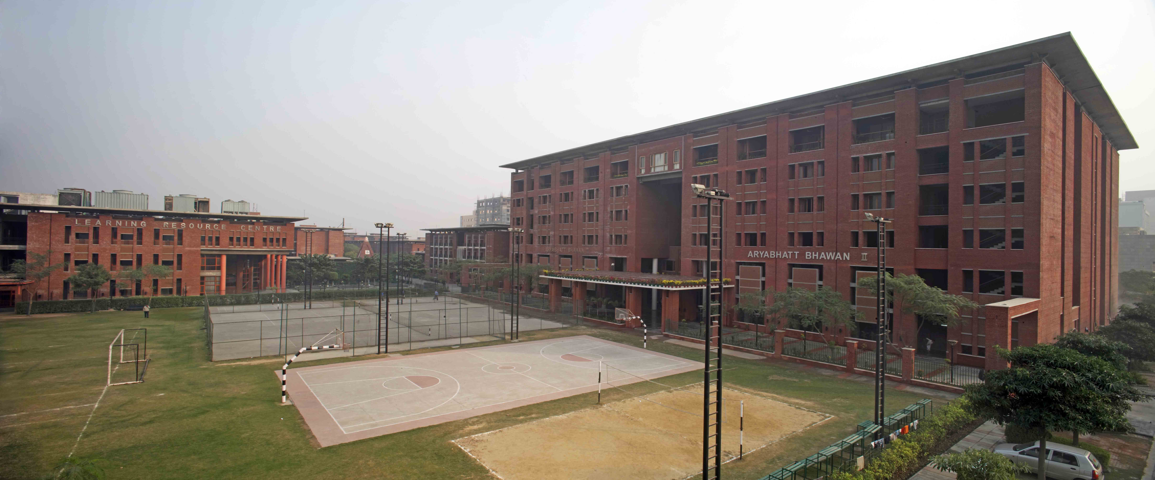
Innovative Approach
The innovative approach of JBS is reflected in the Four distinctive V's of Jaypee Business School: They are Vision, Value, Vector and Vitality.
Vision
JBS has chosen to focus on the 'Niche and Sunrise Sectors of India' that require specially trained executives for better service and relationships. MBA programs are sector specific and more industry suited than any generic MBA for greater success.
Value
JBS benefits technically qualified students in order to become more competent and ready for the destined professions. JBS graduates are equally trained in technical and interpersonal interactions - the twin expectations of employers today.
Vector
JBS vectors (directs) its resources towards creating a MBA program with triple specializations. The first is mandatory in service and relationship centricity, the second is optional in any management function (Finance, Marketing, HRM, Consulting and Operations etc.) and the third and final specialization in any industry verticals such as Financial services, Retailing, Skilled Manufacturing, Healthcare and Infrastructure services.

Vitality
Finally, JBS aims to bring a new vitality to all the three campuses of ours at Noida, Guna and Waknaghat with activities, cultural change and plans for the academic, social and leadership development of students, faculty and larger community. JBS 'Netratava' (Leadership Forum) and a mandatory course on Leadership Communication program are examples of the vitality.
Centres of Excellence
JBS has setup three centers of excellence viz. Center for Learning Excellence, Center for Industry Interface and Center for Service Innovation. Each Center aims to 'Pursue, Publish, Practice and Promote Excellence in the Select Verticals of Service and Relationship Management'.
Global Partnership & Linkages
In line with the vision of the Group, JBS has opened discussions with several leading business schools and universities in India and overseas. The School seeks to ally with the Association for Service Management International (AFSMI) - the only global organization dedicated to advance the knowledge, understanding, and career development of professionals in the high technology services and support 'e-business (www.afsmi.org). The School will explore association with the Center for Service Leadership at Arizona State University, USA.
JBS also believes in the power of academic networking around the globe and is in discussion with several universities for exchange and other collaborations for the students and faculty. Student exchange programs exist with select Schools globally. The MBA program provides students with the unique opportunity to study one semester at one of these select B-Schools outside India. These universities include the following:
- University of Massachusetts at Boston, USA
- National Yunlin University of Science and Technology, Taiwan
- Chaoyang University of Technology, Taiwan
- Lunghwa University of Science and Technology, Taiwan
- Cheng Shiu University, Taiwan
- Chienkuo Technology University, Taiwan
- University of Nebraska at Omaha, USA

- Faculty activities
Publications in International Journals
    - Singh, Rahul, Mishra, Jitendra Kumar, Singh, Mahesh Kumar, (2008), The Entrepreneurship Model of Business Education: Building Knowledge Economy, Bulletin of the Szent István University, Gödöll, Hungary, Special Issue, Part II, PP. 629.
    - Mishra, Jitendra Kumar, (2008). Entertainment on Hold – A Case Study; in Focus – The International Journal of Management Digest, 4(1), 65 – 69.
    - Lather, A.S. and Sharma, H. (2009), "Role and importance of training climate for effective training programs", Enterprise Risk Management, Vol. I, No.1, Macrothink Institute, USA.
    - Kanwal, Anil, and Kapoor, Sujata, Determinants of Dividend Payout ratios- A study of Indian Information Technology sector; International Research Journal Of Finance and Economics, Issue 15, May 2008, pp 63-71, 2008.Publications in National Journals

Publications in National Journals
    - Kapoor, Sujata, Relevance of Information Asymmetry Dividend models- A study of Indian FMCG sector; Effulgence, Volume VI , Issue 2, July-December 2008
    - Kanwal, Anil, and Kapoor, Sujata, Relevance of Signaling and Smoothing approaches to dividend- A study of Indian FMCG sector, Business Perspectives, Volume 10, No.1 June 2008.
    - Kanwal, Anil, and Kapoor, Sujata, Relevance of Signaling and Smoothing Approaches to Dividend: A study of Indian IT Sector, Asia Pacific Business Review, Volume IV No.4, October-December 2008
    - Rahul Sharma, Jitendra Kumar Mishra and Naseem Abidi(2008), Implementation of “IFRS”: Issues And Challenges, Review of Business and Technology Research, Vol. 1, No. 1, 2008, pp. 1-8, ISSN 1941-9414.
Papers Presented in International Conferences/Seminars
    - Kapoor, Sujata, Kanwal, Anil and Abidi, Naseem, Determinants of dividend payout ratios- A study of Indian FMCG Sector, The International Conference on Global Issues in Business and Technology, National Institute of Financial Management, India, August 2008.
    - Agarwal, Mohan, S. Suresh, E-shopping Customer Experiences: Modeling and Research Design for Threshold Shoppers, 3rd IIMA Conference on Marketing Paradigms for Emerging Economies, IIM Ahmedabad in Jan. 2009.
Seminar/ Conferences/ Symposia/Short term training programs attended by the faculty
    - Dr. Nripendra Singh attended Workshop on Case Method of Teaching, by Prof. Ravichandran (IIM-A), at IIT-Delhi, December 12-14, 2008.
    - Dr. Nripendra Singh attended Workshop on SAP-LAP Modelling, by Prof. Sushil (IIT-D), at DMS-IIT- Delhi, January 20, 2009.
    - Dr. Hima Gupta attended Two day program on Supply Chain Management organised by Noida Management Association at IMS, Noida, on September17-18, 2008.
    - Ms. Sujata Kapoor, attended One week workshop on Research Methods & data Analyses using SPSS, May 25- 29, 2009, Sponsored by AICTE at Apeejay Dwarka.
    - Ms. Sujata Kapoor, attended AIMA workshop on Recent Advances in Research Methods and Data Analytical Tools, May14-15, 2009.
    - Ms. Sujata Kapoor, attended NEN Foundation Course, April 20-24, 2009 at the International Management Institute, Delhi.
    - Dr. Rahul Sharma attended Excellence in Research and Education Conference, 2009 held at Indian Institute of Management, (IIM) Indore, May 1- 4, 2009.
    - Ms. Vinky Sharma attended AIMA workshop on Recent Advances in Research Methods and Data Analytical Tools, May 14-15, 2009.
    - Prof. G.K. Agarwal attended ICAI Diamond Jubilee International conference at Jaipur, June 16-17, 2009.

CENTRES
Learning Resource Centre (LIBRARY)
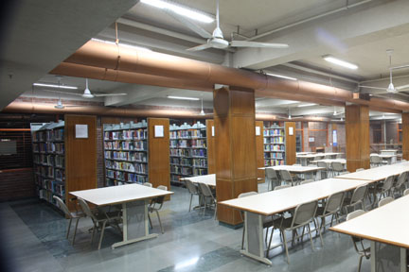
The Learning Resource Centre collectively supports the teaching, research and extension programs of the Institute. LRC has a separate block of three floors, which can accommodate about 350 users at a time. It has sixty four computer nodes with high speed Internet & Intranet connectivity. It is fully integrated with the latest barcode technology and International standard library management software Alice for Windows. Users can access bibliographic details of the LRC resources through OPAC within LRC and via LAN, thus providing 24 hours access a day. The LRC consists of latest collection of textbooks as well as reference books, National as well as International peer reviewed journals, magazines and electronic media sources on subject areas covered by the curricular offerings of the Institute and other universal knowledge. LRC has also made provision to subscribe full text science and technology on-line journals under INDEST-AICTE consortium of IIT Delhi and other National and International journals in printed form. It is also an active member of Developing Library Network (DELNET) and provides inter-library loan service to its users. The open access system has been adopted at all service points where users may browse and select material of their choice. LRC has implemented an anti-theft electromagnetic system at its main gate. It has undertaken two major projects for Development of web based Institutional Repository and comprehensive separate LRC website which will help in developing and exchanging its resources to other organizations.
Objectives
- To provide support to teaching, learning and research programs;
- To accommodate and disseminate universe of knowledge on the focus areas;
- To create best possible environment to users for self learning; and
- To develop a center of knowledge in Engineering, Science & Technology Sector.

Resource Collection
(i) Books (as per Accession Register): 34541

Department Wise
S No | Department | Total No. of Titles (Approx) | Total No. of Volumes (Approx)
1 | Biotechnology | 1724 | 4172
2 | Electronics & Communication | 2070 | 5436
3 | Computer Science & Information Technology | 3073 | 9643
4 | Mathematics | 853 | 2386
5 | Physics | 1876 | 4489
6 | Management | 3993 | 8415
Total |  | 13589 | 34541

(ii) Electronics Resources 27247

E-Journals through INDEST-AICTE Consortium | (ACM - 283)  (IEEE - 219)  (Springer– 801)  (LNCS- 3420) | 4723
EBSCO “Business Source Premier” E-Database | “Business Source Premier”  E-Database | 9474
Company Reports through Capital Line database |  | 13000
E-Books (John Wiley) | 50
Developing Library Network (DELNET-AICTE) | Sharing resources among 1200 libraries world wide with Inter Library Loan Facility
CD/DVD ROMs | There are about 2800 CD/DVD ROMs.

(iii) Print Journals : 67
International : 15
National : 52
(iv) Magazines : 68
International : 05
National : 63
(v) Newspapers (All National) : 36

- LRC activities:
- The Learning Resource Centre (LRC), JIIT University organized International Symposium on “Emerging Trends and Technologies in Libraries and Information Services (ETTLIS)” in collaboration with Delhi College of Engineering and Society of the Advancement of Libraries and Information Science (SLIS), Delhi. More than 250 librarians, academicians, computer professionals and research scholars participated in highly successful and acclaimed symposium.
- Dr. Sanjay Kataria visited Croatia under AICTE –Travel Grant for participating and presenting the paper on Impact of Web 2.0 Technologies in Enhancement of usage of Library Resources and Services: an experimental model @ JIIT University Noida India.” During International Conference on Libraries in the Digital Age (LIDA) 2009 held at Dubronvink and Zadar, Croatia from 25 to 30 May 2009.
- Dr. Sanjay Kataria served as “Resource Person” during the Refresher Course for librarians conducted by Central Tibetan School Administration, MHRD, New Delhi on May 14, 2009.
Resources Added during the year 2008-09
(i) Books (as per Accession Register): 4656

Department Wise
S No | Department | Total No. of Titles (Approx) | Total No. of Volumes (Approx)
1 | Biotechnology | 236 | 588
2 | Electronics & Communication | 267 | 566
3 | Computer Science & Information Technology | 367 | 1134
4 | Mathematics | 151 | 316
5 | Physics | 237 | 392
6 | Management | 760 | 1660
Total |  | 2018 | 4656
(iii) Print Journal : 26
International : 02
National : 24
(vi) Magazines : 31
International : 01
National : 30

IT Infrastructure Centre
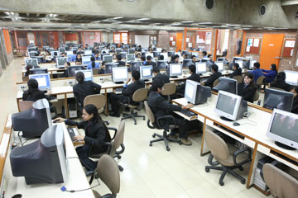
The main objectives of the Server Room ( IT Infrastructure Center) are to provide support to all members of JIITU on all aspects of academic computing, to impalement and maintain IT Infrastructure and application software, to impart introductory and advanced instructions to users, generate trained manpower to maintain IT Infrastructure (Servers, Desktops, Data Security, University Network), to provide support to Institute computerization efforts, to do in house research & development, and to serve a user population of more than 3500 users consisting of undergraduate, postgraduate, research scholars, faculty and staff of the University.
In addition, it also owns the responsibility to develop and implement application softwares for various needs of University like finance, payroll, results, MIS reports and electronic attendance system etc.

- General Computing Facilities.
The Server Room is equipped with Intel Nehalem Quad-Core Servers for high performance windows 2008 Computing Server, Intel Xeon servers with multiple processors, High end Intel Pentium servers with multiple processors, various engineering and technical computing softwares, network management tools, Client/Server Database computing System connected over a switched fast Ethernet with Optical Fiber backbone.
For the printing needs we have 12 heavy duty Network Laser Printers and two Line matrix printers.

- Hardware Configurations
Servers (Qty-21)
- Intel Nehalem Quad-Core Servers with 6GB RAM, 300*4 HDD with RAID5 (Qty 4)
- Xeon Servers 4GB RAM 72*4 HDD with RAID5 (Qty 10)
- Xeon Series File storage server 1024GB storage space, 4GB RAM and with RAID5 (Qty 1)
- Intel P-IV Servers 1GB RAM, 32*2 / 72*1 B HDD (Qty 6)
Desktops (Qty-1070)
- IBM Core2Duo Desktops with 3.0GHZ Processor, 2GB RAM 160GB Sata GB HDD, 17” Color Monitor (Qty 75).
- HP Core2Duo Desktops with 3.0GHZ Processor, 2GB RAM 160GB Sata GB HDD, 17” Color Monitor (Qty 200).
- HP/ IBM P-IV Desktops with 512/ 256MB RAM 80 /40 GB HDD, 15” Color Monitor (Qty 425).
- Compaq/HP Desktops with 256/ 128 MB RAM, 40/20 GB HDD, 15” Color Monitor (Qty 295).
- HP Desktop core 2 duo with 1.8GHz, 512MB RAM, 120GB HDD, 17” Color Monitor (Qty 75).
- Engineering, Technical Computing and General Use Softwares.
MATLAB. | RATION ROSE | Lotus Domino
MATHMATICA. | MEMSPRO. | Lotus Smart Suite
MODELSIM. | HYPERCHEM. | Softimage
LAN Tanner. | Cisco Works | Visual Prolog
PSPICE. | Zen Works. | SPSS
3-D Max. | Schrödinger | Visual Studio .NET
MOE | Adobe Suite | MS Project
NETWORK SIMULATOR. | Borland C++ | MS Office
FPGA. | Macromedia | Symantec Antivirus
SOFTIMAGE. | Photoshop pe | Oracle 11g
ANIMO. | Illustrator pe

- Database Service
The Server Room has a Client/ Server Database Computing System- Oracle 11g with Developer 2000 version 6.0. at the front end, the platform is Windows 2000/ XP / 2003 and at the back end, Nehalem Quad-Core Based Windows 2008 Enterprise.

- Network Services
The institute Local Area Network (LAN) is a state of the art switched network with Fiber Optics and enhanced CAT5/CAT6 UTP Backbone. It consists of more than 5000 network access points spread using 65 Cisco Switches, 2 Routers and 15 VLANs. The network access is provided to every room in student’s hostel, faculty & staff residence, doctors at JIIT Hospital, cafeteria & mess (Annapurna), laboratories and rooms in guest houses.
Internet connection has been provided through a router, Cyberoam firewall. We have 8Mbps (1:1) leased circuit from BSNL on OFC. Apart from Internet and Intranet many more services including mail, web, library book search, domain name, anti virus and software upgrades are being provided over this network.
JIIT is using Cyberoam Suite to manage Internet bandwidth and mailing services. Cyberoam is consists of software firewall, anti spam controller, content filtering and anti-virus protection at gateway level. Lotus Domino is being used by JIIT for its official mailing services.
- New Additions:
Desktop Systems : IBM/HP 275 Nos.
Server Systems : IBM 4 Nos.
Firewall : Cyberoam UTM 2 Nos.
Network Switches : Cisco 10 Nos.
Printers Network : HP 5200 LaserJet 3 Nos.
Mailing Software : Lotus Domino Server
Antivirus Software : Symantec Endpoint Protection Suite
Server Software : Windows 2008 Server Licenses

MISCELLANEOUS ACADEMIC ACTIVITIES
Important Events Conducted by the Departments:

- CSE/IT
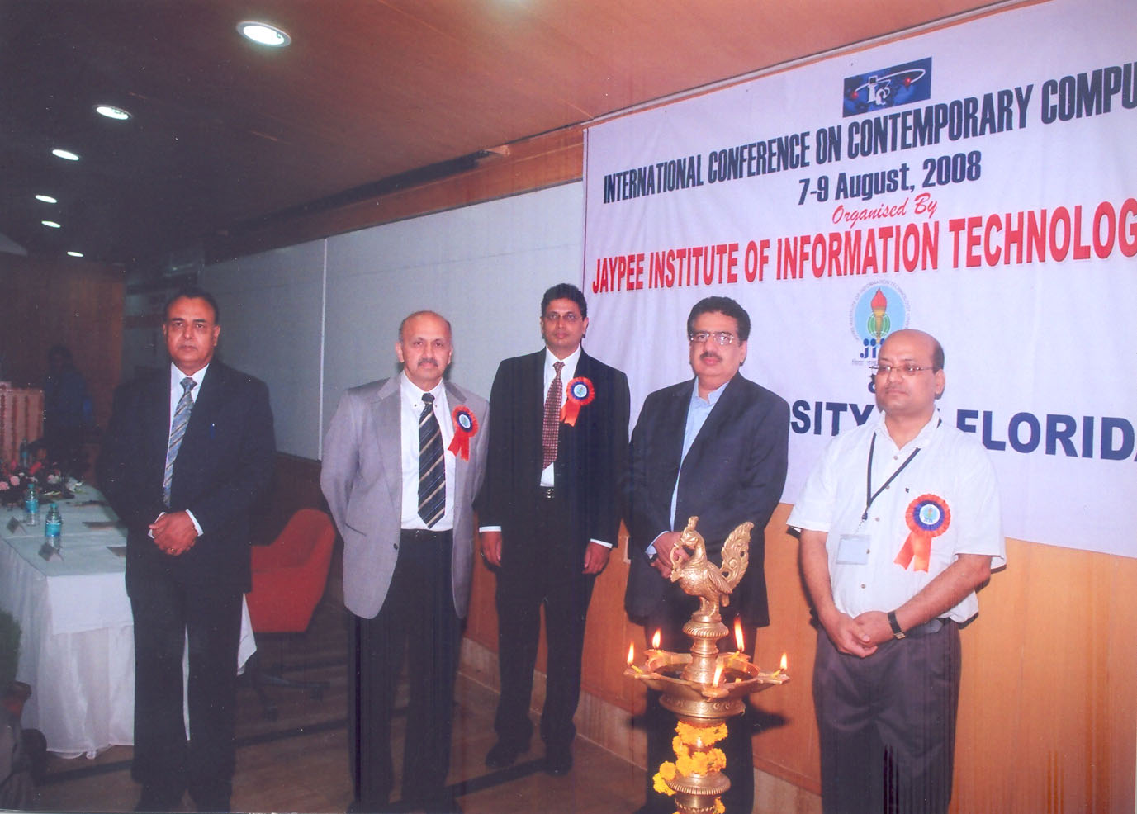
- The Department organized The International Conference on Contemporary Computing-2008 (IC3-2008) jointly by the University of Florida, Gainesville, from 7th Aug-9th Aug, 2008.
The Eminent keynote speakers were :
  - Prof Pradeep Khosla of Carnegie Mellon University spoke on
  - Prof S. Sitharama Iyengar of Louisiana State University,
  - Prof Sartaj Sahni, of University of Florida,
  - Prof Pankaj Jalote of IIT Delhi, Pradeep Khosla of Carnegie Mellon University,
  - Prof Rajeev Kumar of IIT Kharagpur,
  - Prabhakar Raghavan of Yahoo Inc,
  - Prof Sanjay Ranka of University of Florida,
  - Prof Rajiv Sangal of IIIT Hyderabad.
  - Prof. Srinivas Aluru of Iowa State University spoke on “The Combinatorics of Sequencing the Corn Genome"
- A total of 100 papers were received out of which 30 were selected for presentation by an international panel of experts. The conference proceedings were published by M/s McMillan Publishers.
- The Department organized a Workshop cum Competition on Computer Game Design on 4 Feb, 2009.

- ECE
- Intensive workshop on “SPREAD SPECTRUM TECHNIQUES AND CDMA” organized at JIITU, Noida on 14 Dec, 2008. This was attended by about 80 participants.

- BIOTECHNOLOGY
- A DBT sponsored National conference on “Biodiversity and Agribiotechnology”, Department of biotechnology, JIIT University, Noida, April 25, 2009
- The Biotech society of JIITU, RIBOSE organized a literacy workshop on “National Education day” on Nov.11, 2008.
- RIBOSE also conducted a "Climate Change Orientation Program" on 22 April 2009 to mark “Earth day”.

- PMSE
- One day Workshop on "Fundamentals & Applications of Optics" sponsored by NASI & OSA– Delhi Chapter on Saturday 20th September, 2008.

- JBS
September 11, 2008 - JBS HR club organized an “HR Conclave”. Speakers of the occasion included Ms. Pria Warrick, President & Executive Director, Personality Labs & Warrick Finishing School (Ex Miss India, USA), Mr. Vipul Prakash, CEO, Elixir web solutions Pvt. Ltd. and Mr. Sanjiv Kumar, Vice President (HR), Infoprocorp.

Lectures/Talks/Workshops/Presentations/Seminars/Discussions by Guest Speakers
- “My Story” a Session for Entrepreneurial Development Course students by Harpreet S. Grover, Founder, Co-cubes.com on July 31, 2008.
- “Entrepreneurial World” Lecture for Entrepreneurial Development Course students by Ms. Kalpana Sinha Consultant NEN on July 24, 2008.
- “Idea Generation Workshop” for Entrepreneurial Development Course students with NEN on August 12, 2008.
- “My Story” a Session for Entrepreneurial Development Course students on August 19, 2008 by Mr. Rahul Agarwal Principal Consultant & Facilitator Pro-Life Consulting.
- “Intellectual Property Rights and Cyber Crimes” for the students of Social and Legal Issues, by Ms. Yashi, September 5 and 6, 2008.
- “Online Marketing” a lecture by Mr. Kapil Nakra CEO & Co-founder OMLogic on Sept. 16, 2008.
- “Object Oriented Software Engineering” a lecture by Professor Rajeev Kumar, Computer Sc.Deptt. IIT, Kharagpur. on 18th Sep-20th Sep 2008.
- “Intellectual Property Rights and Cyber Crimes” for the students of Social and Legal Issues, by Mr Sumit Agrawal, September 19 and 20, 2008.
- MILLIDAY -ULTRAPURE WATER: Its contaminants, purification technologies and use in life science applications, Nishant Bhargava, Marketing Specialist, Lab Water (Millipore) Gurgaon, 22 October 2008
- Opportunities and challenges in Clinical Research, Dr. Meeti Behl, Institute of clinical research, India on 12 November, 2008
- Overview of IPR spectrum and NRDC role in Technology Transfer in India, Bijaya Kumar Sahu, Scientific Officer, National Research and Development Corporation, Government of India, New Delhi, 21 January, 2009
- “Data Mining Applications in Agriculture” a lecture by Dr. Leisa Armstrong, Professor, Computer Sc.Deptt. Edith Cowen University, Australia on 4th Feb, 2009.
- “RFID: Technology and Applications” a lecture by Mr. Christopher Mark Bolan from Computer Sc.Deptt. Edith Cowen University, Australia on 4th Feb, 2009.
- Prof. R.. S. Chhikara, Department of Mathematics & Statistics, University of Houston, U S A visited the Department on Febuary 04, 2009 and delivered a talk on the topic “Beyasian Analysis of the Inverse Gaussian Distribution”.
- “Video Processing using fuzzy logic and neural network“ a lecture by Prof. K.K Biswas, Professor, Computer Sc.Deptt. IIT Delhi on 7th Feb, 2009.
- “Emotional Intelligence” a lecture by Y.N. Kaushal Director, Enablers Management Institute on 09 Feb, 2009.
- Smart Polymers, Dr. Sania Akhtar, Deputy Director, Central Institute of Plastics Engineering and Technology, Mysore, 10 February, 2009
- Prof. P. N. Rathie, Department of Statistics, University of Brasilia, BRAZIL has delivered a talk on “ Lambert W-Function, Statistical Distributions and Reliability Analysis” on Feb. 25, 2009.
- “Software Architecture” a lecture by Mr Arun Kumar Gupta, Manager - Accenture, Gurgaon, on 27th Feb, 2009
- “Drug Information Database -Thomson Micromedex” a lecture by Adarsh Nigam, Vans Information Ltd., Bangalore, 1 April, 2009
- “DATA STRUCTURE” a tutorial by Prof Phalguni Gupta, Distinguished Professor, Computer Sc.Deptt. IIT Kharakpur, from 21-22nd March,1st April and 13th April, 2009.
- Prof. C.K. Raju, Director (Academic), INMANTEC Ghaziabad & Professor Centre for Studies in Civilizations, New Delhi has delivered a talk on “Calculus Without Limits” on April 8, 2009.
- “Role of Pharma in 21st Century”, a lecture by Dr. Vinay S. Bansal, Senior Consultant, Health Management Research Institute, Hyderabad, on 20 April, 2009
- Prof. S. L. Singh, Former Principal, College of Sciences & Engineering, Gurukula Kangri University Hardwar has delivered a talk on “The Recent Developments in Computational Techniques”, on April 22, 2009.
- “ISO-22000-Food safety management system” a lecture by Abhishek Tyagi, Coca cola Industries Gurgaon on 30th April 2009
- “Project Management/Product Implementation” a live talk by Mr. Saurabh Sharma from Nucleus Software Ltd. on 12th September, 2009.

Miscellaneous:
- A leading Biotechnology magazine, Biospectrum (August 2009) ranked the Department of Biotechnology 3rd amongst the Private Biotech Education Institutes.
- Books published
- A B. Bhattacharyya, “Compact MOSFET Models for VLSI Design,” Wiley and IEEE Publications, 2009
- M.Srivastava, M.C. Srivastava and S. Bhatnagar, “Control Systems,” McGraw Hill Education (TMH), 2008.
- Akhter, “Digital Hardware Design,” University Science Press, 2008.
Awards/Achievments
- Prof A B Bhattacharya has been awarded ISA Technovation Award, 2009
- Aayushi Gupta was adjudged as the winner of the BOLT District Award 2008-09 organized by Air India & Dainik Jagran for Gautam Buddh Nagar district.
- Arpita Sharma and Aayushi Gupta’s research paper titled "Identification and Correlation of Software Project Risks for Excelling in IT Industry” was selected as one of the 10 best papers presented in the International Conference on "Doing Business in India ' held at IFIM Business School, Bangalore in Dec 2008.

Visits
- July 6-8, 2008 - Prof. M.R.B. Wahiddin, Head, Cyber Security and Information Lab, MIMOS, Kuala Lampur, Malaysia.
- August 19, 2008 – Hon’ble Sh. Tarun Kumar Gogoi, Chief Minister of Assam.
- January 12, 2009 : Mr. Tony Harker, Director & Chief Executive – ISLI and Mr. Pnku Biswas, Country Representatives (India) visited the University and organized a seminar on ‘Educational Opportunities (Engineering) & Funding options available in the UK.
- February 04, 2009 : Students and Faculty of Edith Cowen University, Australia visited the University besides interaction a Guest lecture was conducted on “Data Mining Application in RFID” by Mr. Christopher.
- February 25, 2009 : Prof. William Webster, Member Board of Management and former Vice-Provost, University of California visited the University and interacted with students and Faculty.
- March 04, 2009 : Ms. Luna Das Bangia, Educational Advisor North India, United States-India Educational Foundation (USIEF) visited JIIT to conduct an information session on “Opportunities for Higher Education in the United States”.
- Drs. Syed Haque, and Dinesh P Mital, Department of Health Informatics, University of Medicine and Dentistry of New Jersey, March 16, 2009.
- Prof. Sartaj Sahni, distinguished professor and Chair, CSE, University of Florida visited the University on few occasions to draw out the details of mutual understanding to move the students for 8th Semester program at the UF.

Ongoing Projects Sanctioned by Govt. Agencies
Project Co-ordinator | Research Area | Funding Agency
Dr. R.C. Jain  Dept. of ECE | IP Core for Real Time Audio Video Surveillance System | AICTE: Research Promotion Scheme
Dr. Sanjay Gupta  Dept. of Biotechnology | Mapping Viral Host Protein Interactions of Chikungunya Virus | AICTE: Research Promotion Scheme
Dr. Sudha Srivastava  Dept. of Biotechnology | Designing a Nanoparticals Based Glucose Biosensors. | AICTE: Research Promotion Scheme
Dr. Krishna Asawa  Dept. of CSE | Psychic Monitoring and E-Counselling System | AICTE: Research Promotion Scheme
Dr. Sanjay Gupta  Dept. of Biotechnology | Viral-viral and viral-host protein interactions in Chandipura virus mediated encephalitis | Department of Science & Technology (DST)
Dr. Rachna  Dept. of Biotechnology | Scientific Documentation and Digitization For Selected Indian Medicinal Plants For Antidiabetic and Other Activities | Ayush (Ministry of H.R.D.)
Dr. Krishna Sundari  Deptt. of Biotechnology | Formulation of Microbial Consortia with Parallel and Biocontrol Properties | Department of Biotechnology (DBT)
Dr. Vibha Rani  Deptt. of Biotechnology | Cardio Protective Properties of Curcumin: Molecular Interaction of Cardiac Transcription Factors” | Department of Science & Technology (DST)

INTERNATIONAL LINKAGES:
The Institute has developed collaboration with some foreign educational Institutes.

- University Of California Berkley Extension (UCBE), USA.
The MOU aims at:-
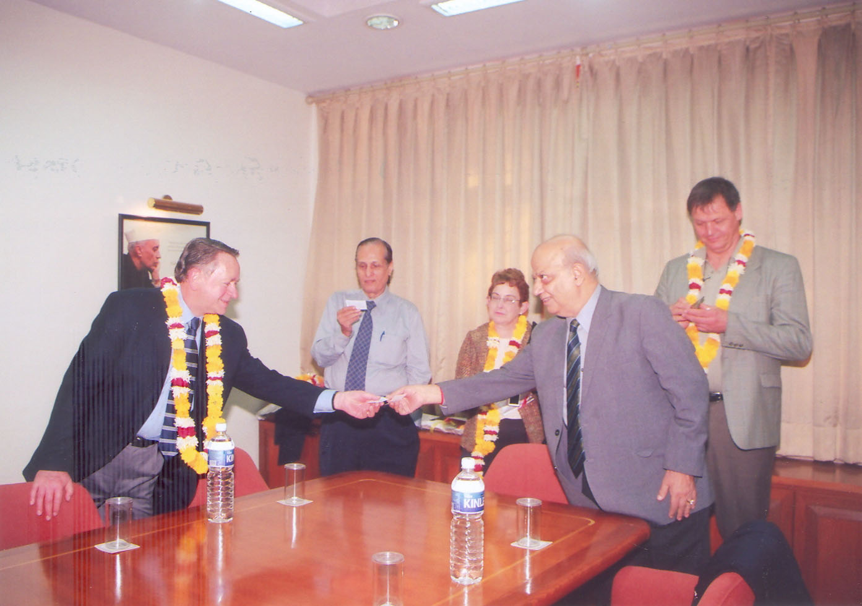
- Cooperation in mutual fields of academic interest for purpose of developing specific education and training opportunities and programs.
- UCBE provides academic & organization development assistance as well as education & training activities in number of fields and subjects including:-
- Design of curricula.
- Development of appropriate faculty profiles.
- Internship opportunities with United Sates companies.
- Establishment of periodic quality assurance practices and procedures.
- Distance learning opportunities.

- Mapua Institute of Technology, Manila, Philippines.
The MOU aims at:-
- Implementing a student exchange program. This program is on a one-to-one basis. The students bear their own travel and living expenses. The exchange students take cultural-related courses, above the science and technology courses, to make the program more meaningful.
- Sharing faculty resources for mutual benefit.
- Creating a group of Asian, European and US Schools, that will formulate and adhere to represent certain standards in IT education.

- Prof Entian Group at Institute Of Microbiology, Johann Wolfgang Goethe, University Of Frankfurt, Germany.
The memorandum focuses on:-
- Providing specialist advise on an Individual / Institutional basis
- Advising and assisting in development of course curricula.

- Universities of Applied Sciences Finland.
27 Rectors signed a Memorandum of Association aiming at exchange of programs, faculty and students for developing the ties to enhance the cooperation in University education.

- Youth Development Fund Bhutan
The MOU aims at:
- Long terms association between the people of Bhutan and Jaypee Group, India.
- It assures 20 scholarships every year to cover cost of tuition fee, lodging at Institutes of Higher Learning of Jaypee Group.

- University of Florida
Gainesville, Florida, United States of America The primary objective of this agreement is the development of cooperative efforts between Florida and Jaypee, which will enhance the academic interchange between the two institutions, promote exchange between the faculty and students of the two institutions as well as the exchange of academic and research information

- The University of Nebraska at Omaha
The primary objective is to promote contact and collaboration between faculty, staff and students, carry out joint research programs and exchange experiences in education and research. The partnership also aims at enhancing the technological, social and cultural relations of both countries/states/regions. This document presents a general framework for such a partnership. It also includes some specifically identified areas of cooperation:

- Exchange of information and experience:
- Faculty and student exchange programs:
- Cooperative research projects:
- Coordinated graduate degree program:
- Continuing and distance education:

- The University of Westminster, London, England
The primary objective is to :
- Explore collaborative development in selected areas based on common interest.
- Development of Joint delivery post graduate program.
- Creation of jointly supported staff development program.
- Consultancy work to assist the development of new postgraduate courses.

CONVOCATION
- The Institute held its 5th Annual Convocation on 17 March 2009. The function was graced by Shri Gulam Nabi Azad, Hon’ble Member of Parliament, Rajya Sabha, and now Minister of Heath and Family Welfare who delivered the
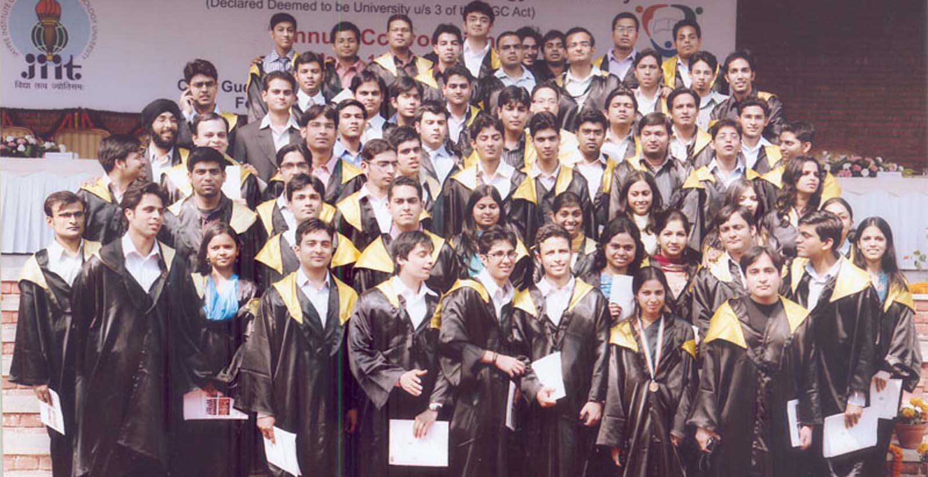
- The report presented by the Vice Chancellor is attached at Appendix-B.

ACADEMIC ADMINISTRATION
Admission Process
- UG Program:

The admissions in the academic session 2008-09 were carried out through a counseling process conducted by the Institute, based on all India merit in AIEEE rankings.
Further admission to the Dual Degree Programs in Pharmacy were carried out based on merit in the 10+2 examination

- PG Program:

The admission for M. Tech programs was based on GATE score / Entrance Test conducted by the Institute for eligible candidates.

Similarly admission to MBA program was based on CAT/MAT/XAT Score followed by Group Discussion and Interviews.

- PhD:

The selection is done through an interview of short listed scholars, based on their Qualifications and credentials.

- Admissions (2008)
The details of Admission carried out in the Academic Session 2008-09 were as follows:
Programs No. of Students
4 Yr B. Tech (CSE, ECE, IT & Biotech) 453
5/6 Yr Dual Degree Programs 163

(The admissions to the above program was based on merit in AIEEE all India rank.
The minimum AIEEE rank in B. Tech CSE was 6083 while the maximum rank in B. Tech-Biotech was 52738 for the B. Tech programs. Similarly for the Dual Degree Programs the minimum rank was 12631 for Dual Degree Program B. Tech-MBA in. The admission to the 6 Years B. Pharm-M. Pharm practice program was based on merit of 10+2 exam.)
M. Tech Programs - 33
(Based on GATE score and PGET-2008)
2Yrs MBA Program - 145
(Based on CAT/MAT/XAT Score and merit drawn after GD/PI)
Doctoral Programs - 11
(Based on recommendations of the Research Board)

Faculty
- The Unique feature of the Institute, despite being at nascent stages of development is the high quality of faculty on its rolls. The brief on the Faculty giving its terminal qualification is as Appendix-C.
- Visiting /Adjunct Faculty
The Institution further has some eminent Academicians as also eminent industry person on its rolls as visiting faculty for conduct of specialised classes. Currently there are 4 adjunct and 31 visiting faculty members associated with the University. In addition specialists’ faculty of institutes of JES in respective fields also visits all the Institutes of JES.

Results:
The performance of Students in the Institute is graded in terms of Semester Grade Point Average (SGPA) and Cumulative Grade Point Average (CGPA) over a scale of 10. A typical analysis of results of even semester-2008 is given at Appendix-D.

Scholarships
- Prof William C Webster Merit & Means Scholarship: Jaiprakash Sewa Sansthan has set up an initial corpus of Rs. 20 lacs for the Prof William Webster Merit Cum-Means scholarship. The scholarship is provided to the students admitted to the Jaypee Education System across the three campuses. Eligible students get a tuition fee waiver for the year upto a maximum of Rs. 25,000. The scheme was started in the year 2004-05.
- The Jaypee India Scholars Fund : has been launched to provide financial assistance to meritorious students with poor financial and economic conditions for pursuing higher technical education (4-year UG program) in the Jaypee Education System. Under the scheme financially and economically poor students would be provided financial assistance of Rs 1.05 Lacs each every year for pursuing the 4-year UG program starting from the admission year 2008 in the Jaypee Education System. The scholarship will be available for all the 4 years of their study, provided they maintain a minimum performance every year in their respective program of study. The unique aspect of this scholarship scheme is that such students will also enter into an undertaking to repay back the total scholarship amount over a period of 3 years, post graduating from the Institute.
- Admission To Meritorious Students : The Management has approved that students who take admission in the first year of the 4-year UG program, with an All India Rank of less than 1000 in the AIEEE-2008 conducted by CBSE, shall be provided free education for the entire duration of under graduate program.

JIITU YOUTH CLUB
JIITU Youth Club (jyc) is the sole student body of the JIIT. The objectives of JYC are:
- Furthering holistic development of students
- Provide a climate that nurtures the overall development of students
- Create an environment that is trusting and spontaneous;
- Encourage flexibility, celebration and recognition.
This is achieved through annual cultural, technical fests, various events, contests, sports meets, excursions and other spontaneous activities that help maintain high levels of enthusiasm and team integration. Focusing on technical, literary, sports, and cultural scopes these competitive activities, apart from serving as a relief from intense academic load, present an opportunity to instill confidence, encourage teamwork and give students a strong sense of achievement and belonging.

Cultural Society:
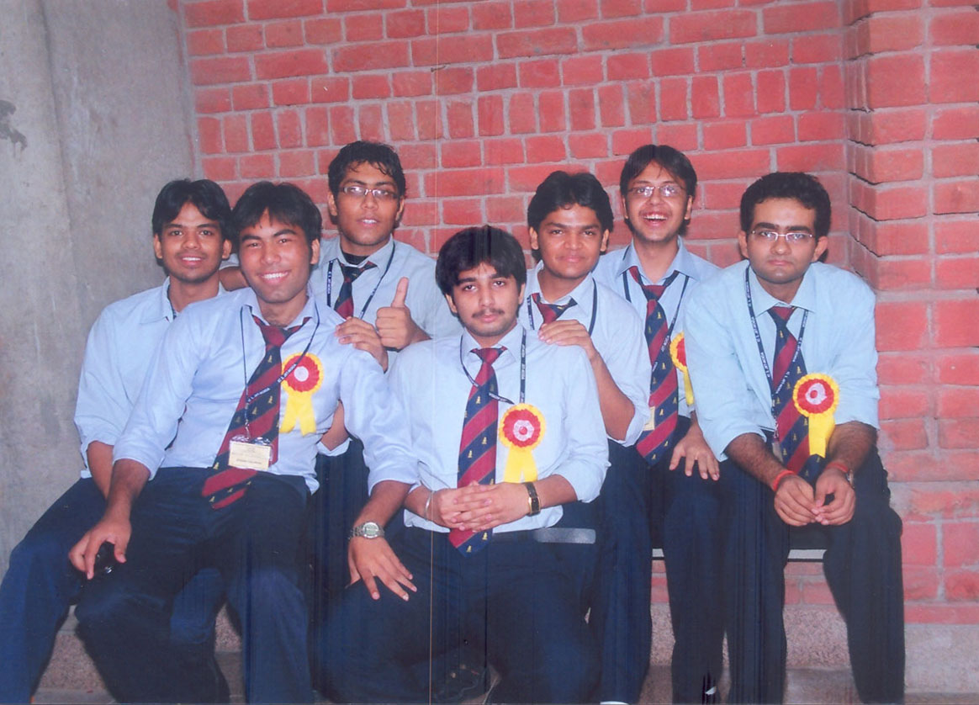
The Cultural Society works closely with emerging talents and budding artists from the theatre, music, dance and classical arts. These synergies result into an array of sensational cultural events. It conducts periodic events and workshops on regular basis.

Technical Society:
Technology and Innovation, these two are the words that take the center stage when it comes to the Technical Society of Institute. It organizes frequent programming contests and technical workshops in the campus with the intention of imbibing creativity in technical innovation. It also boasts of an active Robotics cell.

Creative Society:
At creative society, there is a characteristic inculcated that is to concentrate and feel a sense of self in art. Along with offering artistic and innovative publicity solutions for all the events of the university, the Creative society encourages, enhances, and identifies creativity among the students.

Literary Society:
This society celebrates literary talent and organizes Literary Events and activities throughout the year. The society also publishes the College Newsletter, ‘Kriti’ at regular intervals.

Sports Society:
This society nurtures the sports talent of the students in sports such as football, basket- ball, badminton, swimming, cricket, volleyball, tennis, table-tennis, carom, chess etc. The college has won many sports laurels in intercollegiate events around the country.

Activities organized by JYC

- Acquired Membership of Spicmacay.
- Organized Cultural night of Odyssey dance, by Mrs. Sangita Dash.
- Organized College Trip to Nainital-Ranikhet-Corbett National Park.
- Sent a six member College students team to Jaypee Vidya Mandir, Annopshaher for a six day intensive Math session for 10th and 12th board appearing students besides guiding them with career options.
- Organized Intra college events: English debate, Quiz competition, poster competition, dance competition, dramatics competition, programming contest
- Organized Intra-college sports series: Varchasva (table tennis, carom, volleyball, basketball etc.).
- Cultural Night to mark the inauguration of new state of art auditorium with a 2000 seating capacity in the JIITU Campus.
- Annual Techno-cultural-literary College Festival – JIVE ’09 (April 16th-19th).
- Farewell for the passing out batch of 2005.
- Ebullience’ 09- Freshers party for the new batch of 2009.

Activities organized by JYC in collaboration with other agencies/NGO’s
- Organized Cultural night of Odyssey dance, by Mrs. Sangita Dash, with SPICMACAY.
- Blood Donation Camp with Lion’s Club
- Voter Awareness Campaign with Jaagore.com
- AIDS Awareness Campaign during JIVE 09 with Delhi States AIDS Control Society (DSACS).

Extra Curricular Participation by College students at Inter Collegiate Level
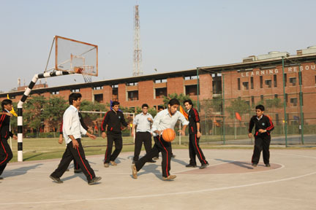
- IIT Roorkee Fest (Saharanpur Campus) [Inter-collegiate]
- DCE fest [Inter-collegiate]
- IIT Kanpur [Inter-collegiate]
- IIT Kanpur Udghosh [Inter-collegiate]
- IIT Kharagpur [Inter-collegiate]
- Rockers India 2009 [National]
- Paper Presentation competition in Jaipur. [Inter-collegiate]
- HP Innovate [National]
- Inter College Sports Meet organized by JIET, Guna.

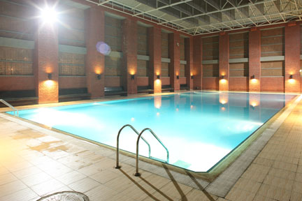
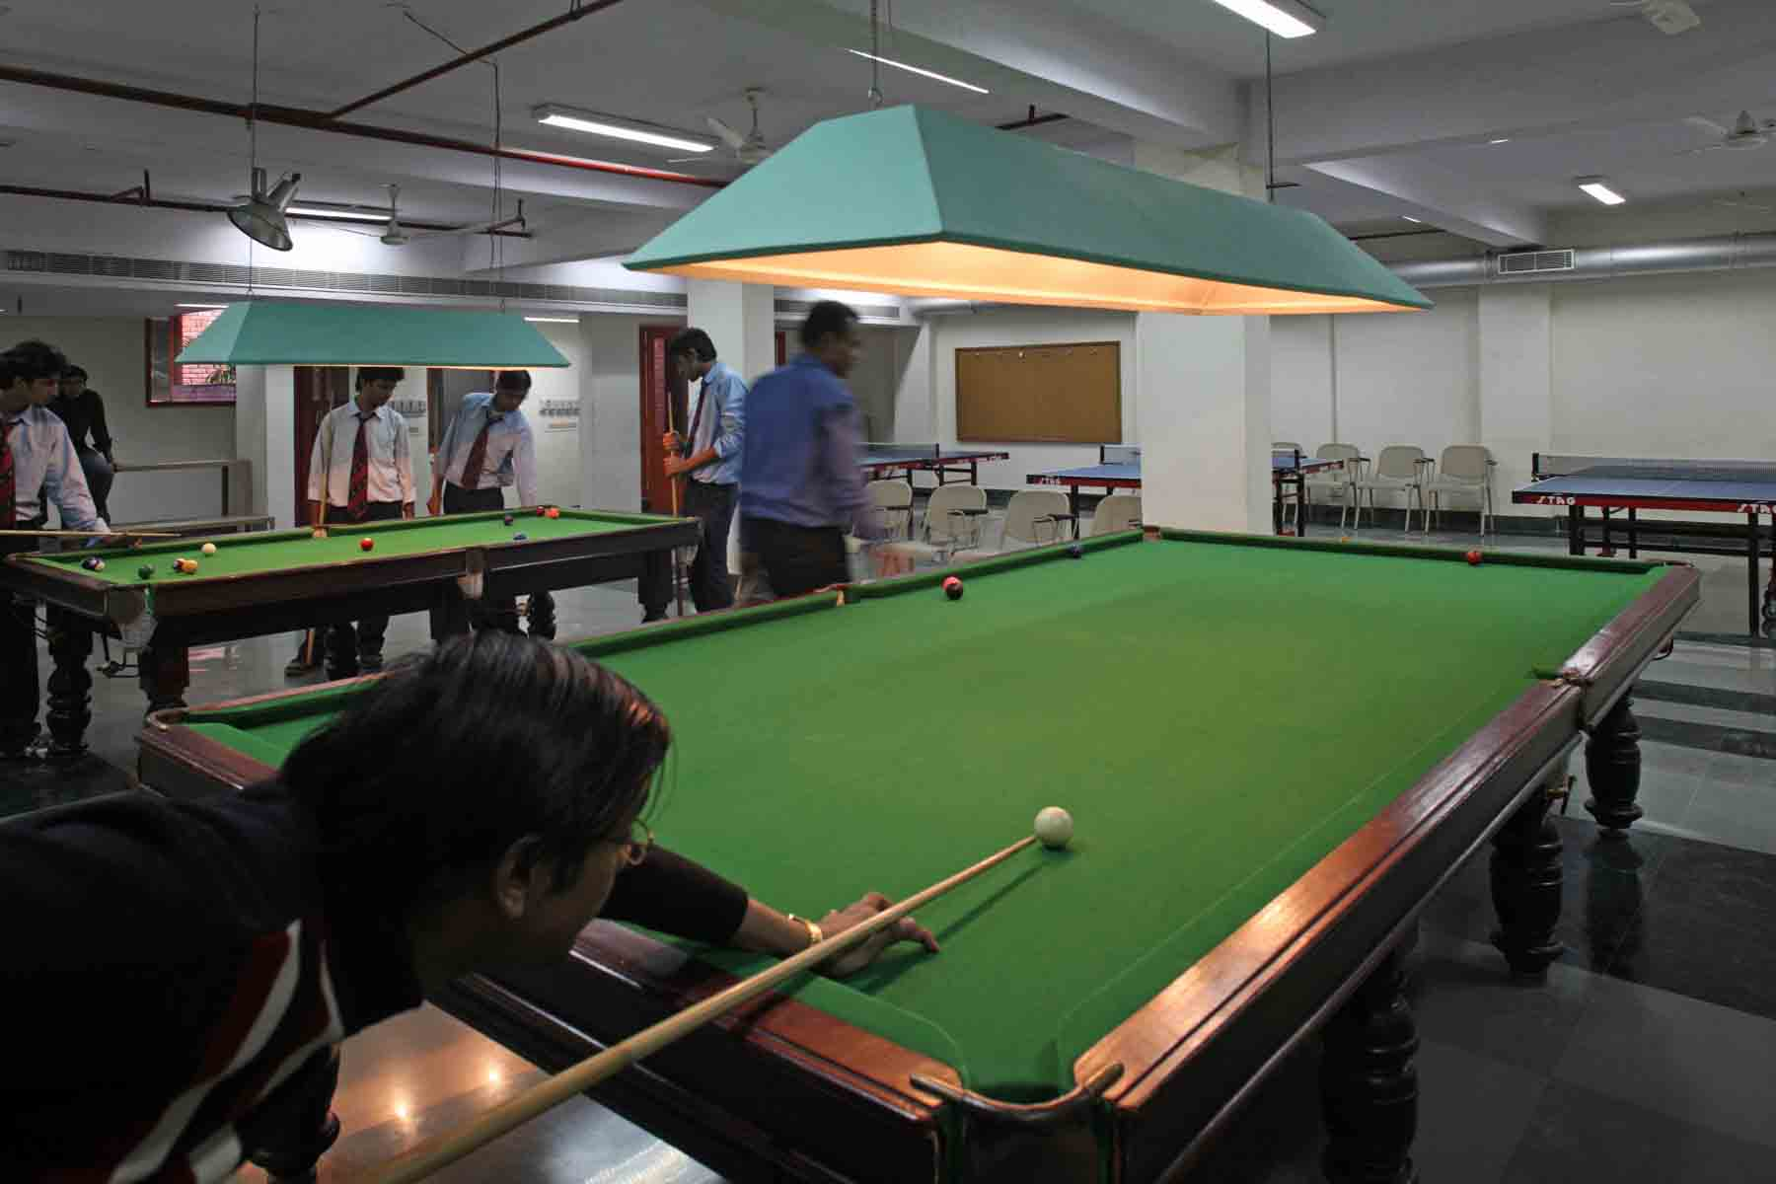

JIVE 09 (April 16th -19th) - THE ANNUAL COLLEGE FESTIVAL

This intercollegiate cultural festival was undoubtedly, the mother of all the events. This festival was organized along the lines of technology and culture fused together topped with various literary events to take away students from the monotony of academia. This three day four night fest, appreciated by one and all, rejuvenated and rocked the spirits of JIITians, needless to mention those of the external participants as well.

GOVERNANCE
Board of Management
- As per Regulations of the Institute, the responsibility for the general superintendence, direction and control of the affairs of the Institute is vested with the Board of Management. The composition of the Board of Management is given at Appendix-E.
- The Board carries out is tasks and functions through statutory committees, which have been specified in the Regulations of the Institute. The composition of standing committees is at Appendix-F.

Academic Council
- The Academic Council is the premier and august body of scholars, which decides and monitors the implementation of Academic policies and profile of the Institute. The powers and functions of the Council are defined in the Regulations of the Institute. Amongst other major functions, the Academic Council controls and approves the courses in various curricula, defines the thrust areas, objectives and constantly reviews the activities of the Departments to ensure improvements in standards.
- The Composition of the Academic Council is listed at Appendix-G.

Supervisory Board
- JIIT has a supervisory Board, under the Chairmanship of Sri Manoj Gaur Ji, for planning, development and overseeing the academic affairs in order to achieve the ultimate Goal of making JIIT a ‘Center of Excellence’. JIIT fortunate to have the following eminent educationists as Members of the Supervisory Board:
  - Prof S.K. Khanna
Former Chairman AICTE, and
Former Vice Chairman UGC
  - Prof M.N. Faruqui
Former Vice Chancellor, Aligarh Muslim University

Advisory Board of JBS
Jaypee Business School is blessed to have the following eminent professionals on its Advisory Board to review and guide its academic policies and directions:
  - Prof S.K. Khanna
Former Chairman AICTE, and
Former Vice Chairman UGC
  - Dr Y. Medury
Officiating Vice Chancellor, JUIT, Waknaghat
  - Prof J.P. Gupta
Vice Chancellor, JIIT
  - Dr. T.N. Kapoor
Former Vice Chancellor, Punjab University
  - Dr. M.P. Gupta
Former Dean, Faculty of Management Studies
Delhi University
  - Prof. Ravi Shanker
Director, JBS

FINANCIAL STATUS
The Audited Balance sheet is attached as Appendix-H.

TRAINING & PLACEMENTS
- An extract of mail from Wipro reflects the Academia – Industry Synergy established by JIIT. Quote “Significant in this quest, is our Wipro Institute Accreditation Framework. Under this we comprehensively analyzed the details of your institute shared by you. Such an extensive exercise led to identification of the best among Indian engineering institutes, from a campus relationship and recruitment perspective. Wipro Technologies is delighted and honored to confer the status of ‘Trusted Academic Partner’ on your institution. We are also happy to announce, the launch of Wipro’s flagship knowledge initiative christened as “Talent ++” which is a bouquet of student engagement initiatives exclusively designed for our accredited partners. We are proud to present an Accreditation Certificate and Plaque to your institute”. Unquote.
- HCL Technologies Ltd., New Delhi and JIIT, Noida
As a part of academia – industry partnership program the company conducted special workshops for the students of JIIT.
- Nucleus Software and JIIT, Noida
Consequent to signing of MOU, several meetings between JIIT Faculty and Nucleus Staff have taken place. Ongoing research projects undertaken by JIIT students have been exhibited to Company and they plan to assign certain live projects to JIIT students under the joint supervision.
- JIIT got its first overseas placement in that Mr. Varun Mittal and Ms. Pallavi Kumar were selected for a Singapore based company with a compensation package of $ 40000 per year.
- Despite recession the Institute had a very satisfactory record in placements for the passout batch 2005-09 and MBA passout batch 2009.
- The placements summary for is attached at Appendix-I.

