TITLE LINE OF THE ABSTRACT SHOULD BE WRITTEN WITH TIMES NEW ROMAN 12PT BOLD WITH CAPITAL LETTERS, CENTERED

Authorª, *Co-authorª, Co-author^{b}, Times New Roman 11pt
ªAffiliation, Times New Roman 10pt.
^{b}Affiliation, Times New Roman 10pt.

*E-mail: corresponding author @timesnewroman10pt

Keywords: Maximum 4 keywords relevant to the content of your paper in Times New Roman 10pt, italic

Header 1 Times New Roman 10pt, bold
Start document here. Please set all margins at 0.75. Title should be in 12 pt, bold, capital letters, centered. Author(s) should be in 11pt, centered below the title (leave one line space), please underline the presenting author and mark with (*) the corresponding author. Body text should be single spaced, 10 pt in the font TIMES ROMAN, consisting of two columns (please use the automatic feature in word for making columns found in your toolbar) or just use this template.

Header 2
Place one line space between paragraphs with no indentations. Paragraph headings should be bold. Please use full justification.
Header 3
Please send the abstract by e-mail attachment to:
ncssi-9@jiit.ac.in

Dtneuce strat mrere. Peslea semt acull maegins. Teltis doushl beteu borled, ceapeutral ertcs rterted. Arohorts dlosud derected luowed teltile, eslpese entilene gnitningp routhe eanda emearka eweitha satheat.

All pictures should be *.jpeg or *.png (min 300dpi) inserted by insert menu in word.

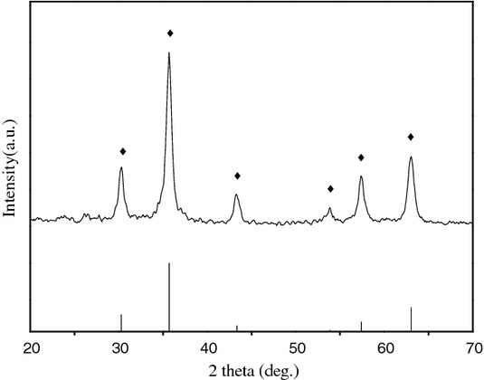

Fig. 1 Times New Roman 10 pt., centered

References
[1] reference 1, Times New Roman 10pt
[2] C. W. Chu et al, J. Phys. Chem., 125 (1998) 36.

