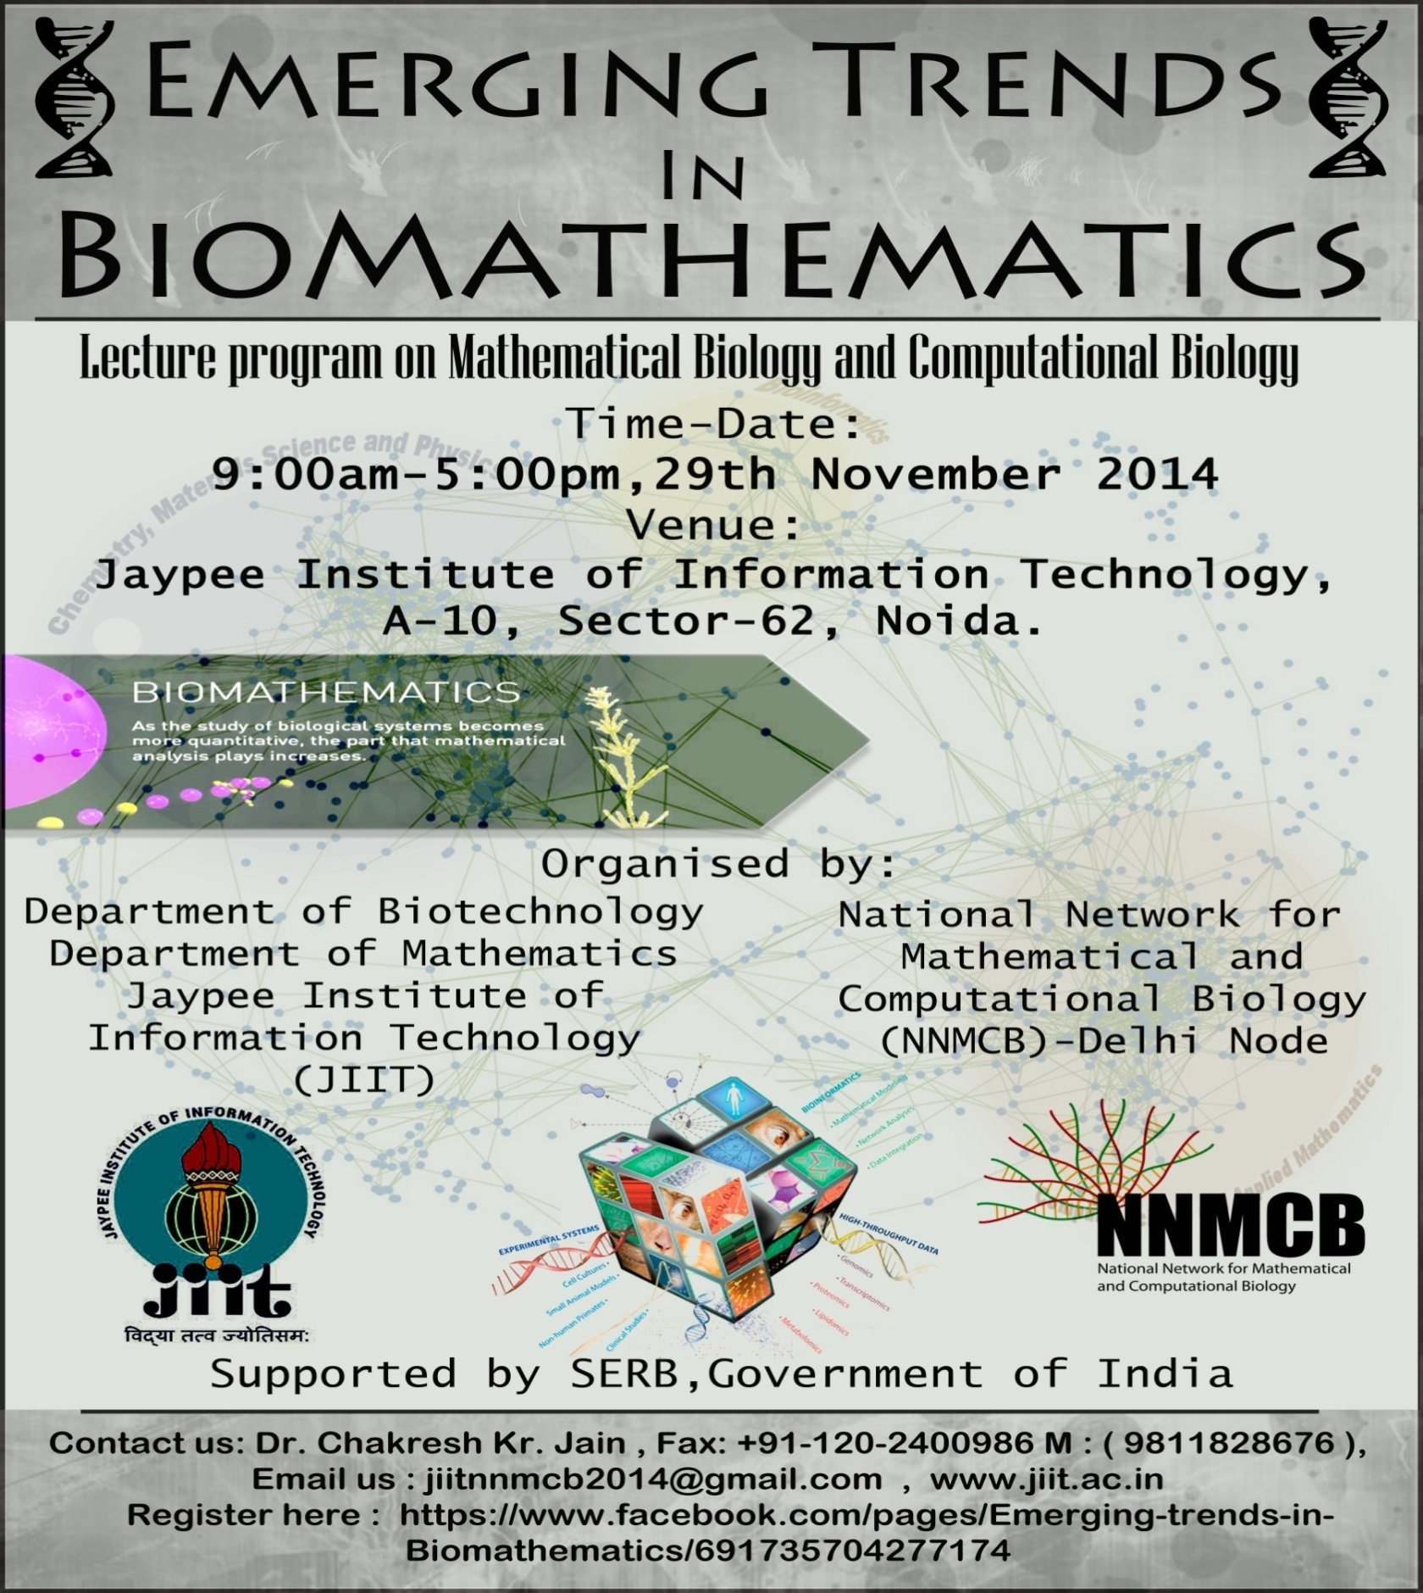
“Emerging trends in Biomathematics”
Lecture Program on Mathematical Biology and Computational Biology
Date: Nov 29, 2014
ORGANISED BY:

Department of Biotechnology/ National Network for Mathematical
Department of Mathematics and Computational Biology - Delhi Node
Jaypee Institute of Information Technology

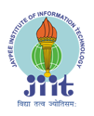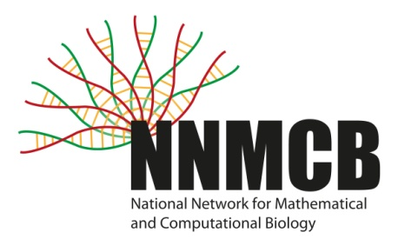
Supported by SERB, DST Government of India

JAYPEE INSTITUTE OF INFORMATION TECHNOLOGY (JIIT), a leading Engineering institute was established in the Year 2001 with the vision of becoming a centre of excellence in the field of IT & related emerging areas of Education, Training and Research comparable to the best in the world for producing professionals who shall be leaders in innovation, entrepreneurship, creativity and management. The Institute offers Doctoral, Post – graduate as well as Undergraduate programs (B.Tech.) of study in the disciplines of Computer Science Engineering, Information Technology, Electronics & Communication Engineering and Biotechnology. The University Aims to Develop engineers with capability to design and implement computer based systems, tools and equipment.

Department Of Biotechnology
The Department of Biotechnology at JIIT, NOIDA, established in 2002, remains committed towards providing research oriented teaching and learning, and a vibrant environment for R&D. Faculty with rich research exposure in academia and industry both in India and abroad contributes to the departmental academic core.
The field of biotechnology is steadily growing in India. Biotech industry achieves record (15 %) growth in 2012-13. In response to continuously evolving technology and industry needs, curriculum is designed to impart skill sets enabling adaptation to academia, research, and industry. The curriculum provides engineering interface and integrates core subject area knowledge with professional development; focusing on entrepreneurship, analytical and research skills. The research emphasis is reflected in the active doctoral program, publications in international/national journals, and sponsored research projects totaling approximately INR-5.07 Crores from premier national funding agencies namely, the Department of Biotechnology (DBT), the Department of Science and Technology (DST), All India Council for Technical Education (AICTE), Indian Council for Medical Research (ICMR) and Department of AYUSH. Interaction with leading scientists from academia and industry through invited lectures, workshops and conferences ensures all-round development of the students.

Department of Mathematics
Department of Mathematics was created from the very inception mainly to cater to the basic needs of the various B.Tech Programs of the Institute. The role and usage of mathematics have since increased manifold in the last decade with the setting in of information revolution which has resulted in substantial changes in not only the curriculum but also the various thrust areas of research such as wavelet theory, biomathematics and new computational techniques. This has put additional expectations on mathematics from the point of view of teaching, research and wide variety of applications.
About the Program: Computational biology is an interdisciplinary science with synergy among different fields of research such as computer science, mathematics, biology, genomics, applied biology etc. This discipline looks to solve complex biological problems with the concepts and theories of mathematics and computers. It involves development and application of data-analytical and theoretical methods, mathematical modeling and computational simulation techniques to the study of biological, behavioral, and social systems. Various mathematical models have been developed to map real life problems in biology.

Objectives:
This lecture session will provide opportunity to the participants to explore many areas of computational biology and biomathematics. The experts shall focus on the implementation of computational and mathematical knowledge for exploring the possible optimal solutions for various biological problems.

Topics:
(1) Computational Neuroscience
(2) In-silico Apoptosis and simulations
(3) Mathematical Modeling
(4) Network Biology and Network dynamics
(5) Stochastic systems

PROGRAMME DETAILS:

Time | Activity
9.00-09.30 AM | Registration
9.30-10.15 AM | Introductory address (Vice-Chancellor & HoD Biotechnology)/ HoD Mathematics
10.15-11.30 AM | Lecture 1: Mathematical Models for HIV infection in -vivo  (Prof Peeyush Chandra IITK, Kanpur)
11.30-11.45AM | Tea break
11.45-1.00 PM | Lecture 2: In-silico single cell biology of apoptotic cell death in healthy and diseased cells (Prof. Subhadip Raychaudhuri, IIITD, New Delhi)
1.00-2.00 PM | Lunch
2.00-3.15 PM | *Lecture3: Topic is awaited  (Prof Sitabhra Sinha, Institute of Mathematical Sciences IMSc, Chennai)
3.15-3.45 PM | Tea break
3.45-5.00 PM | Lecture 4: Computational Neuroscience (Prof. Karmeshu, JNU, New Delhi)
5.00-5.10 PM | Vote of Thanks/ valedictory session/ Certificate distribution

Organizer:
Dr Chakresh Kr Jain, Department of Biotechnology NNMCB-DELHI NODE
Prof Bani Singh, Department of Mathematics
(M) +91-9811828626
Email: Jiitnnmcb2014@gmail.com

Supported by - Science and Education Research Board (SERB), Department of Science and Technology (DST), Government of India

For registrations download form from the following link:
https://www.dropbox.com/s/ts5wfeov4767vzh/Registration_form.dotx?dl=0

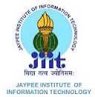 Emerging Trends In Biomathematics 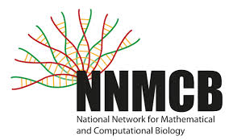
One day lecture program on
Mathematical and Computational biology
29 November, 2014

Registration Form

Full Name: Enter your name here
Name of your Institution:
If other (Name & Address of your Institution): Click here to enter text.
If from JIIT (Select as applicable):
Designation: Click here to enter text.
Mobile: Click here to enter text.
E-mail: Click here to enter text.

Please send duly filled form before 25 November at Jiitnnmcb2014@gmail.com
Please note that registration is free and based on first come first serve (Limited seats are available)

